Jenkins Use Cases

Case 1: Building in Jenkins

Step 1:- Create an EC2 Instance

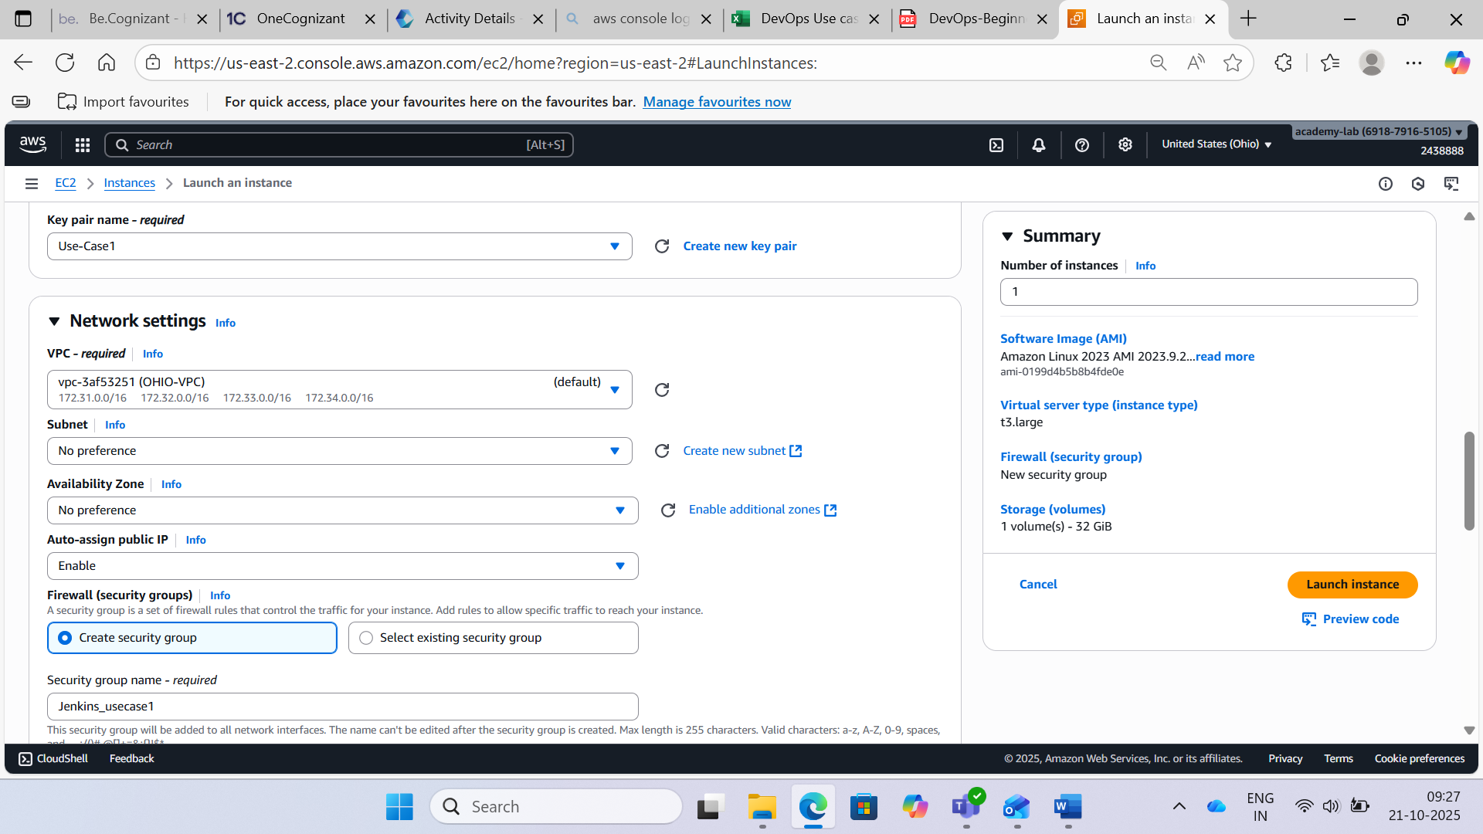

Step 2:- Execute the following command to switch to root user, after connecting with your EC2 Instance: **sudo su**

Update all the packages installed in your EC2 Instance with the following command: **yum update -y**

Install Java to run Jenkins using the following command:

**sudo yum install java-1.8.0**

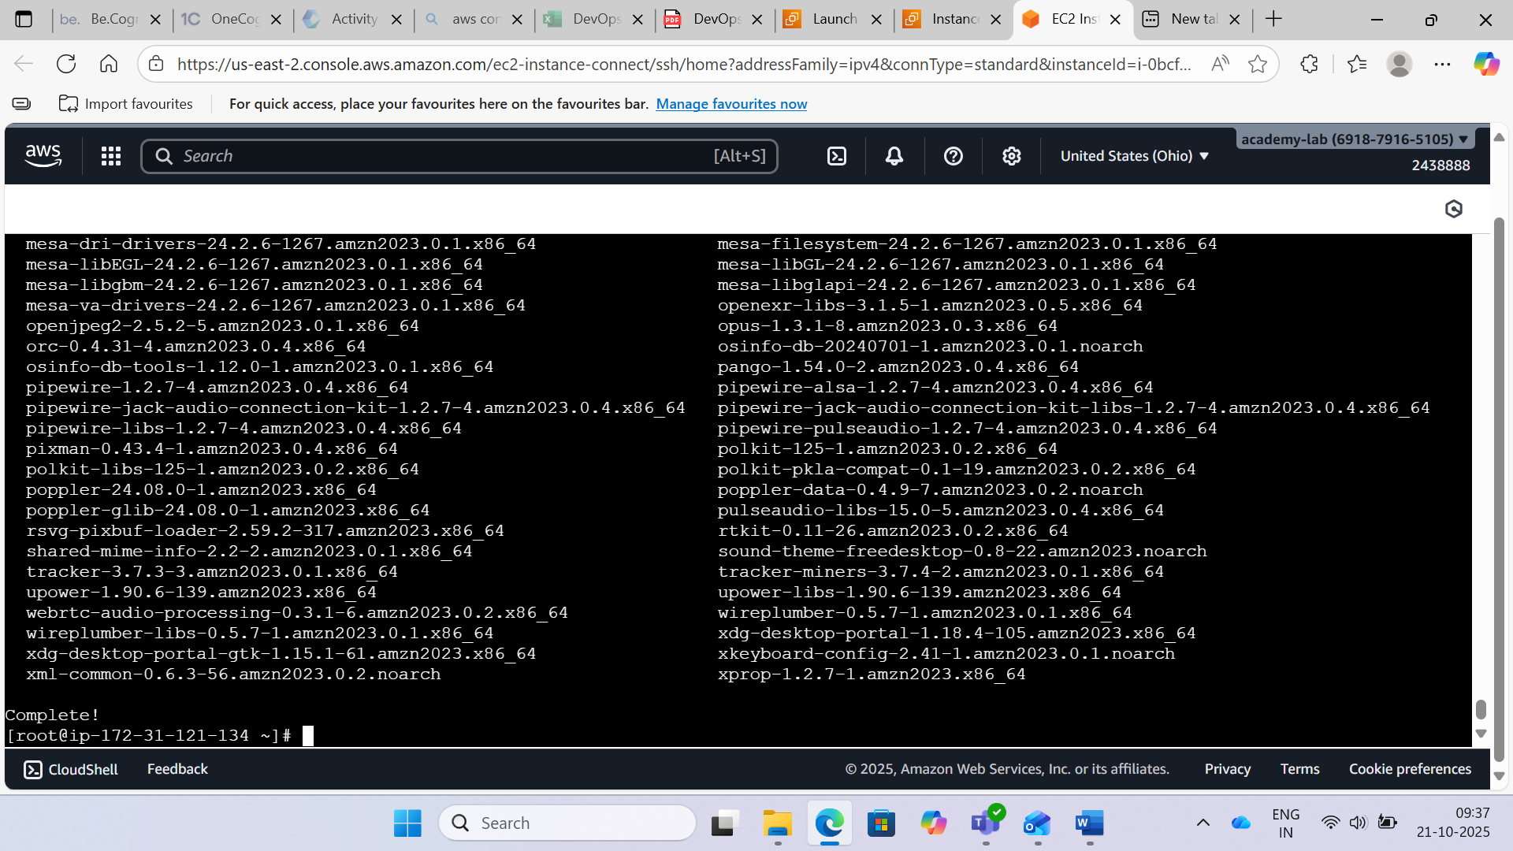

Step 3:- Import rpm package for Jenkins with the following command: **wget -o /etc/yum.repos.d/jenkins.repo http://pkg.jenkins-ci.org/redhat/jenkins.repo sudo rpm --import** [**https://pkg.jenkins.io/redhat/jenkins.io.key**](https://pkg.jenkins.io/redhat/jenkins.io.key)

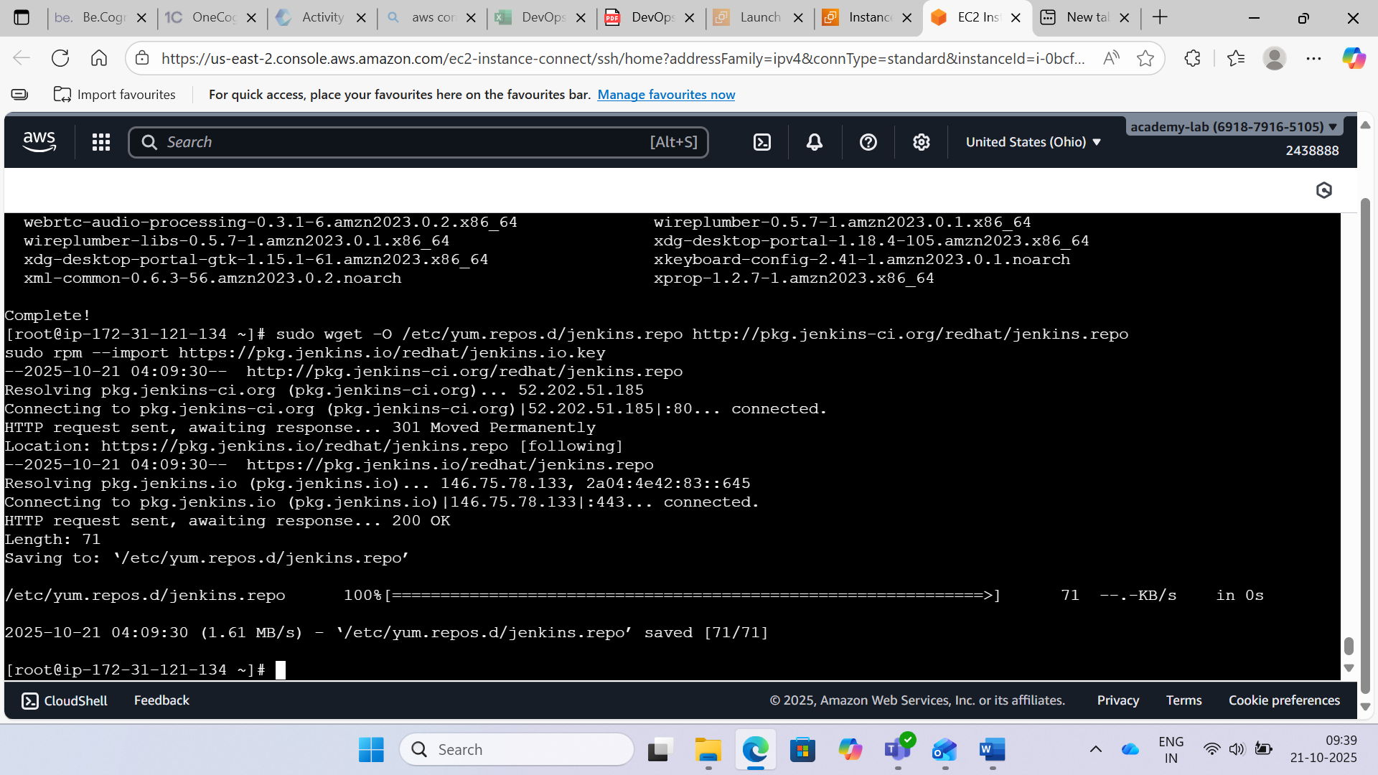

Step 4:- Install Jenkins using the following command: **sudo yum install jenkins -y**

**sudo service jenkins start**

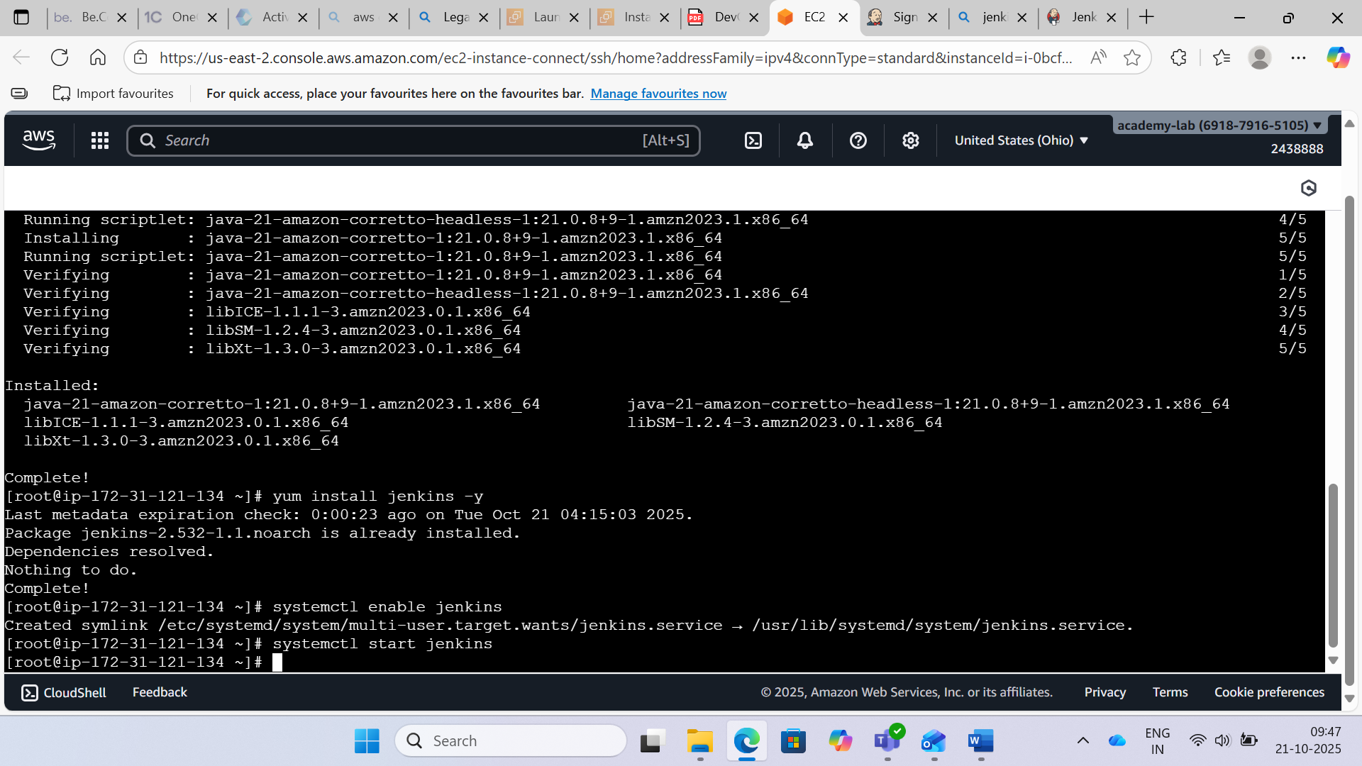

Step 5:- Opening Jenkins using the public ip and port 8080

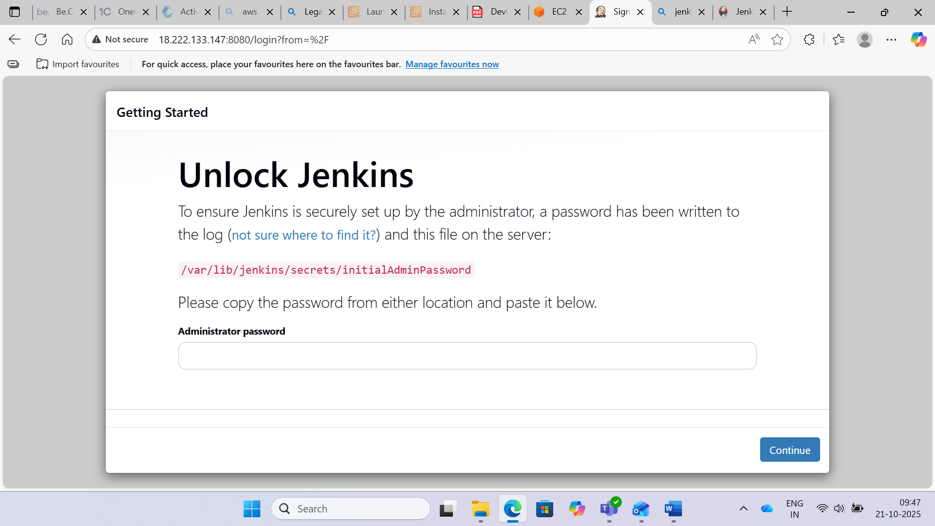

Step 6:- Taking password from the provided path

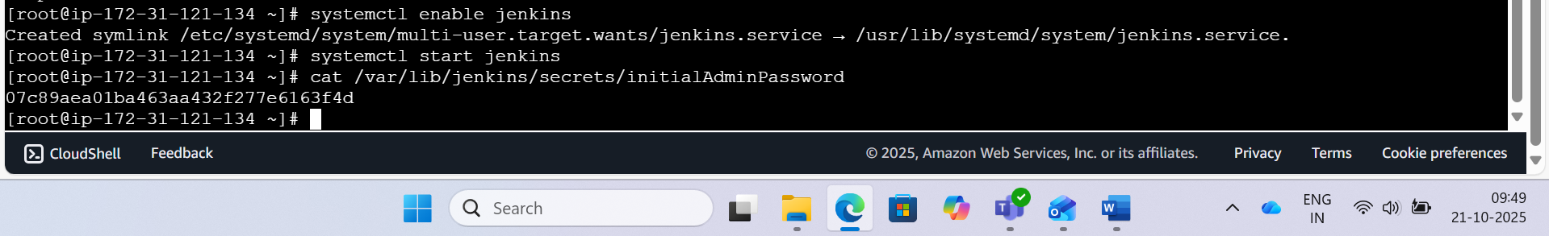

Step 7:- Create a freestyle project and do the following:

Create a user test job that saves it output in a file user_test.txt.

Go to new item on the left pane, in the folder you created.

Name the item use-test and then click freestyle build > ok

Configure the job: Click execute shell in the job configuration page in the build

Type the following in the text box: uname -a && whoami > user_test.txt and click save.

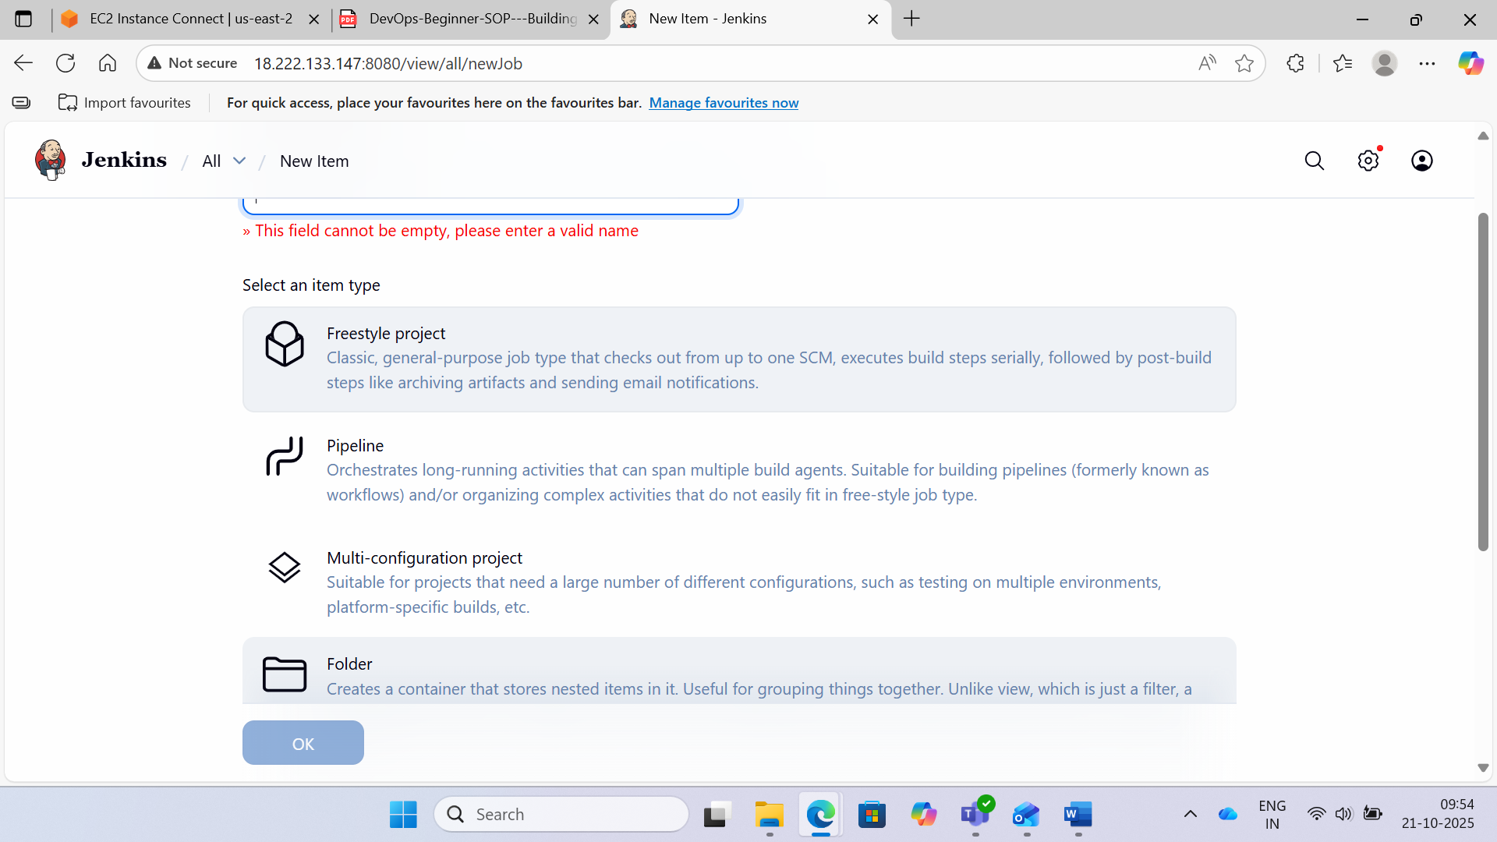

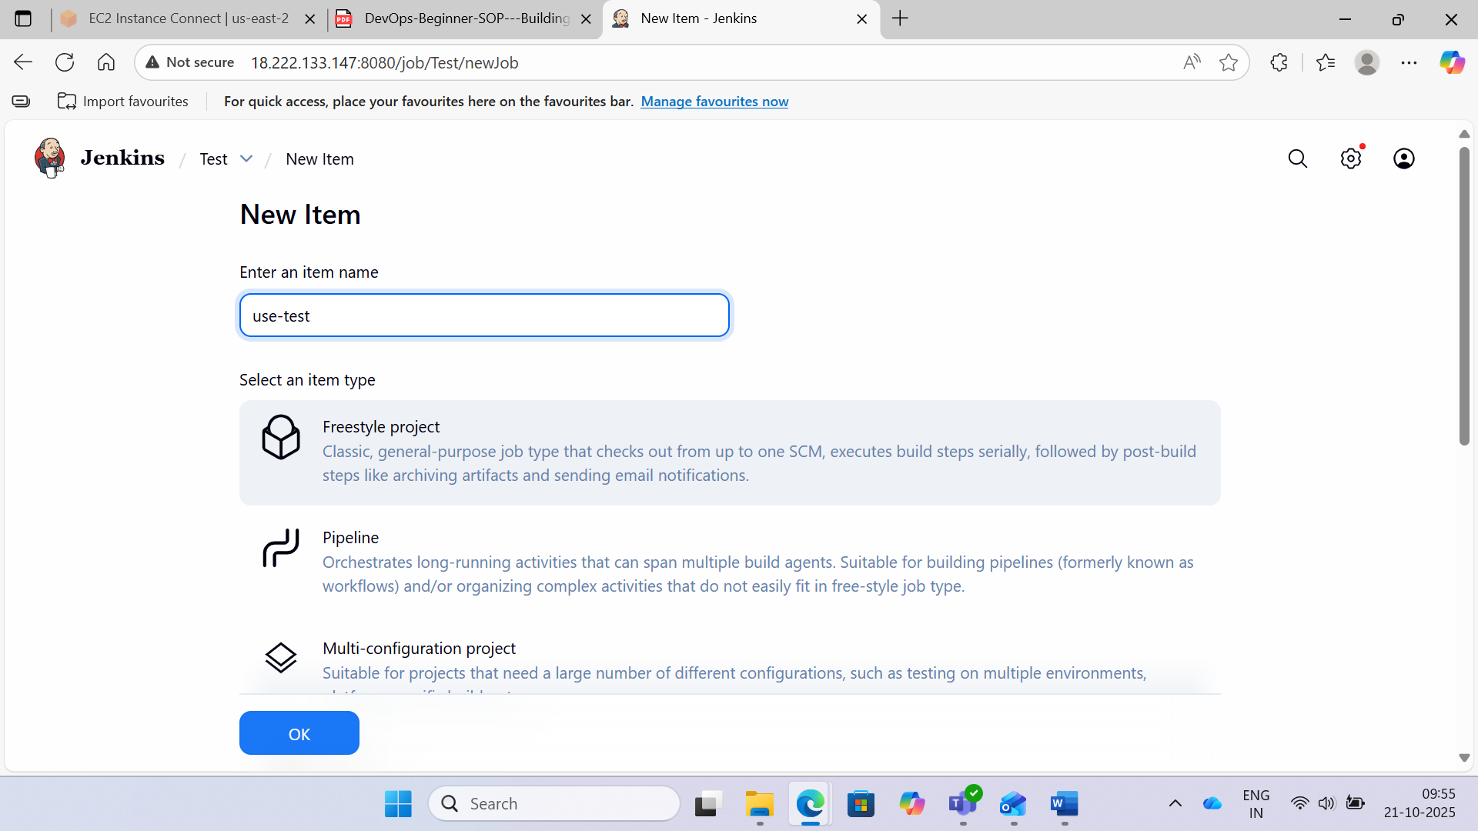

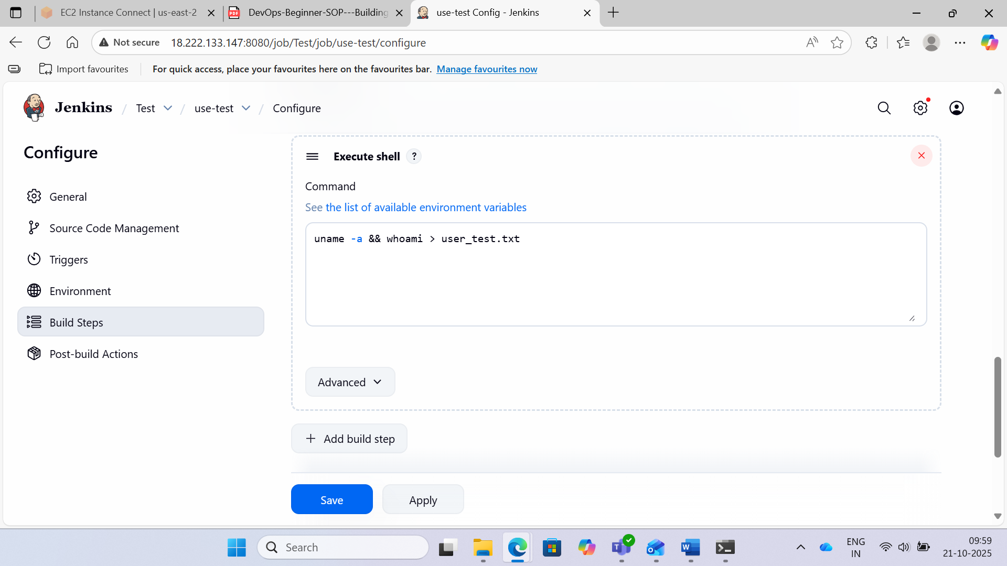

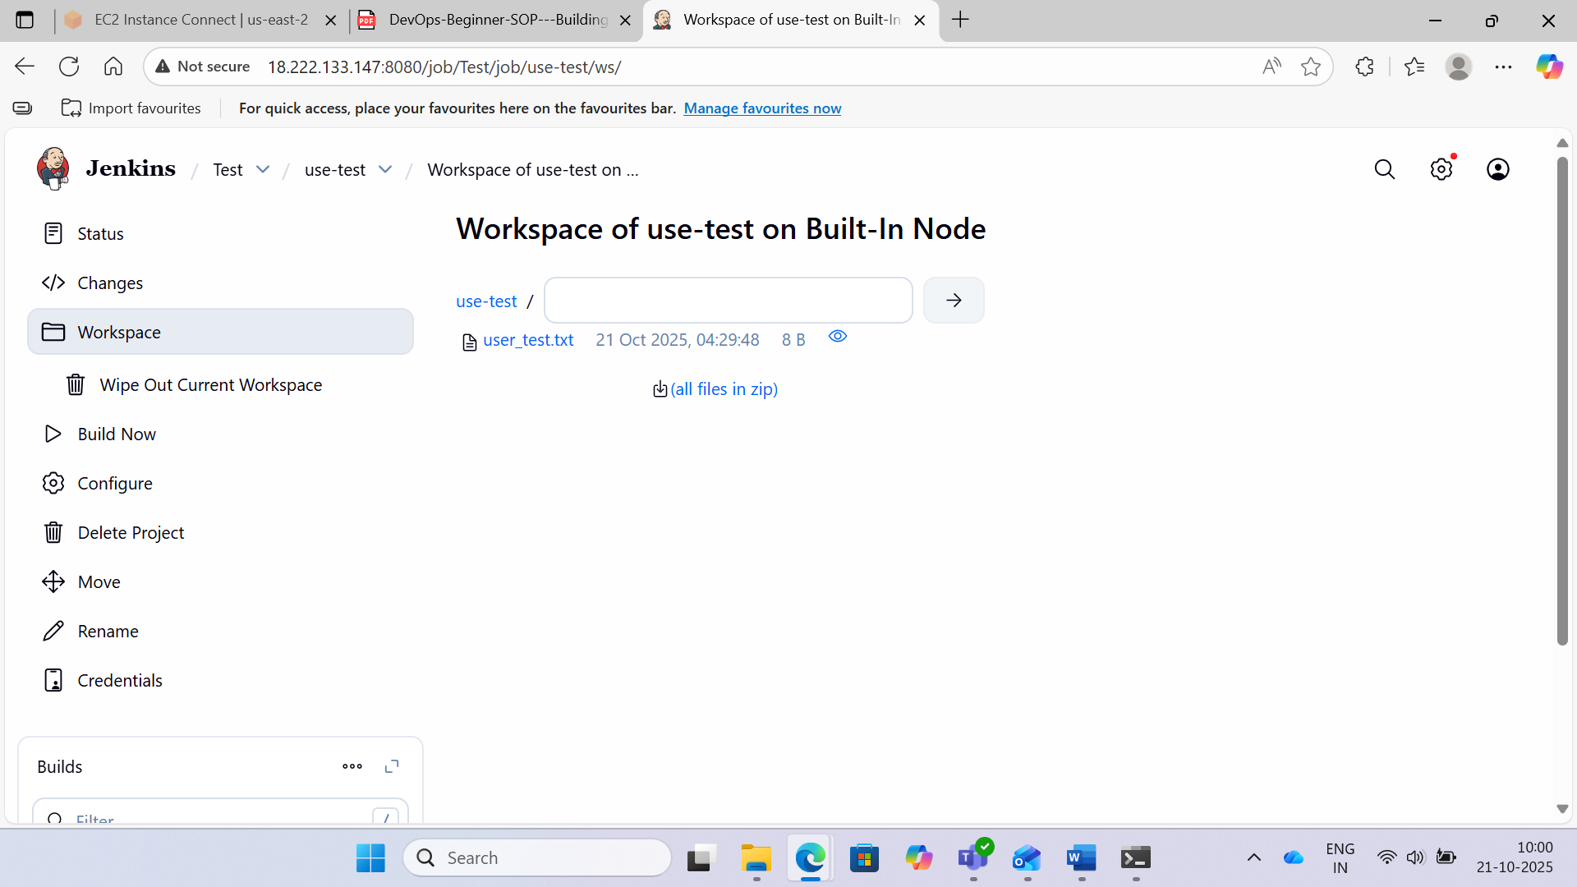

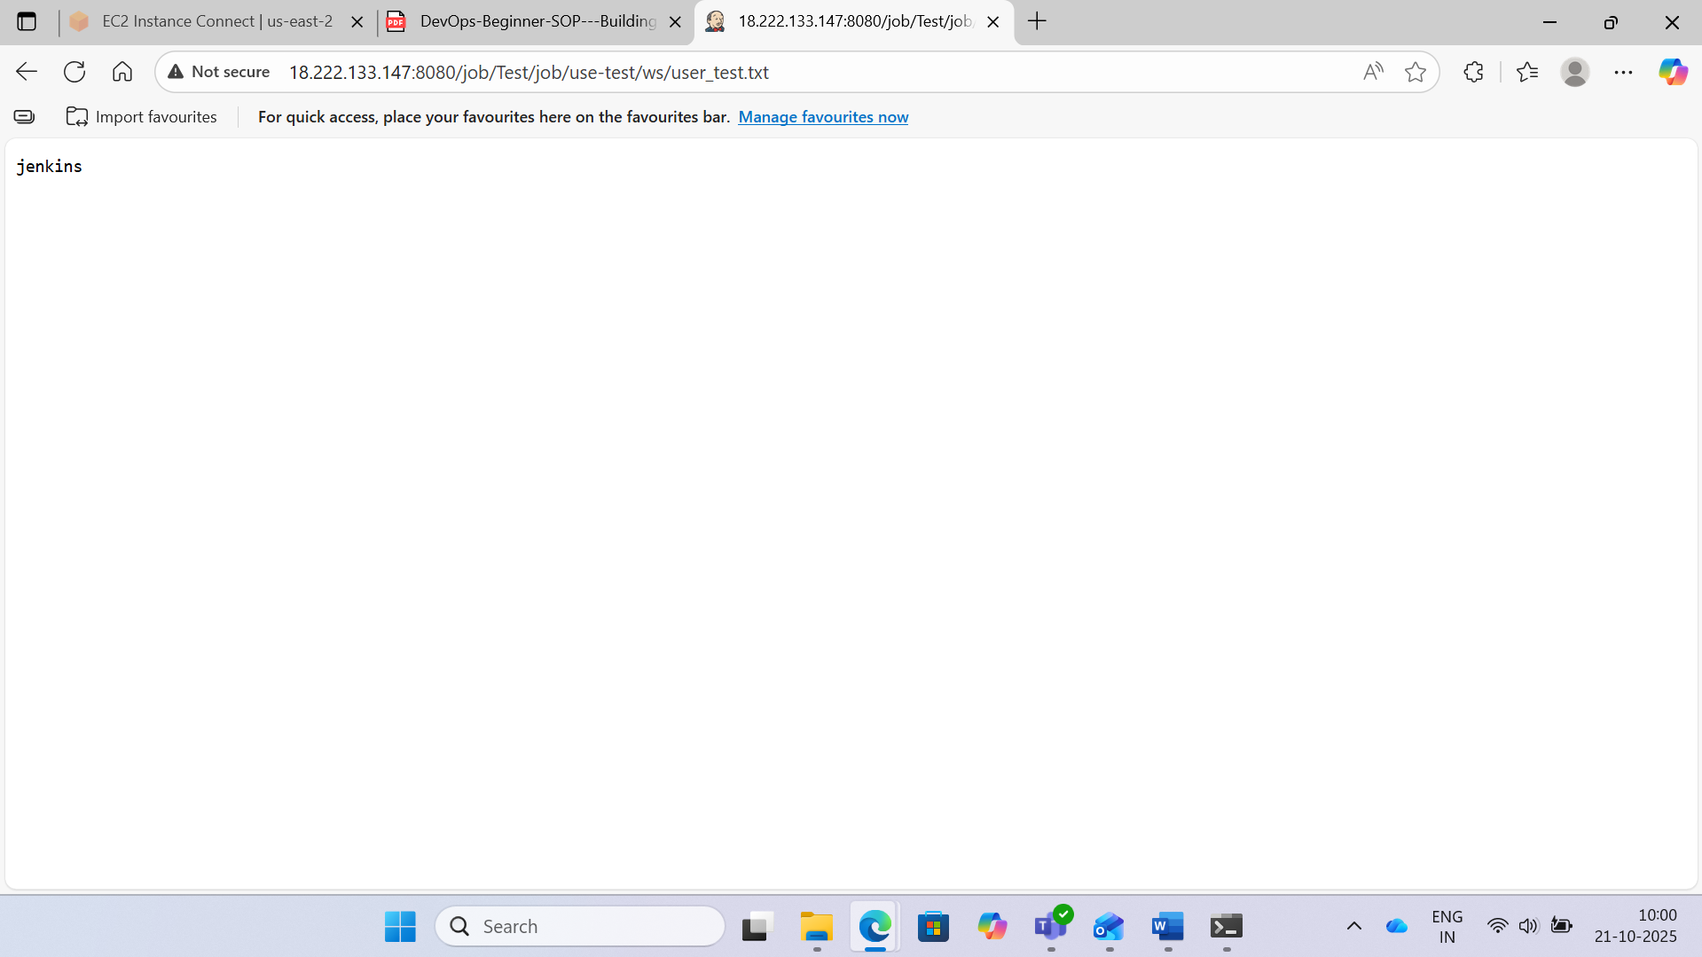

**Use Case 13**

Case 13:- Building a Jenkins Pipeline

Step 1:- Create EC2 Instance and start Jenkins



Step 2:- Open Jenkins



Step 3:- Click on New Item in the left pane of the Jenkins console, and enter an item name (Ex. First Build) and select Freestyle project.

Under Build select Execute Shell and enter command as: echo “My first Build using Jenkins” and click on Save.

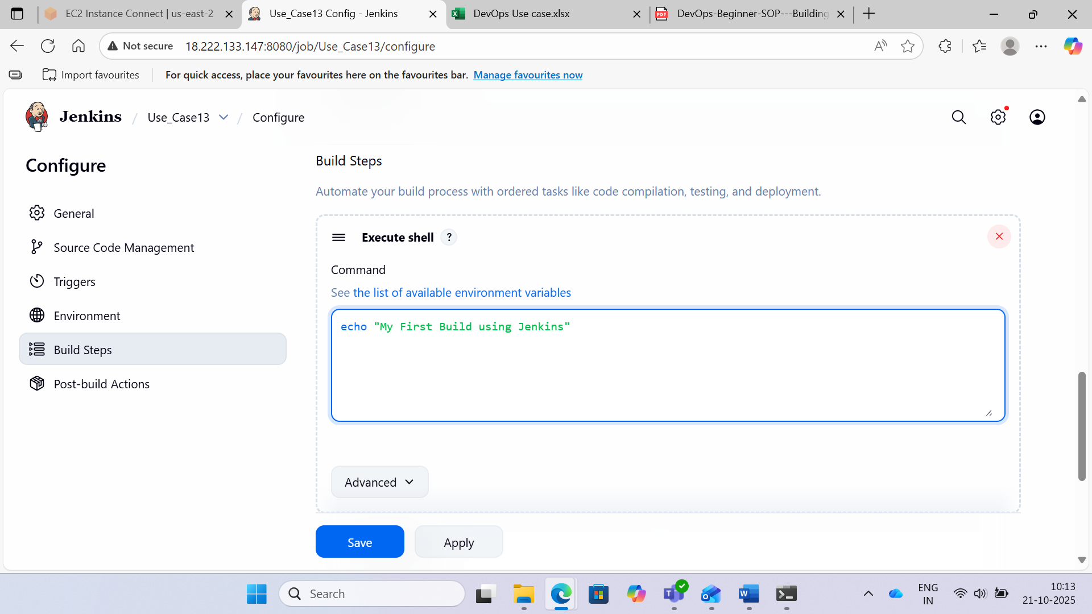

Step 4:- Create two new items (Second Build, Third Build) by following Steps b and c by changing the shell commands.

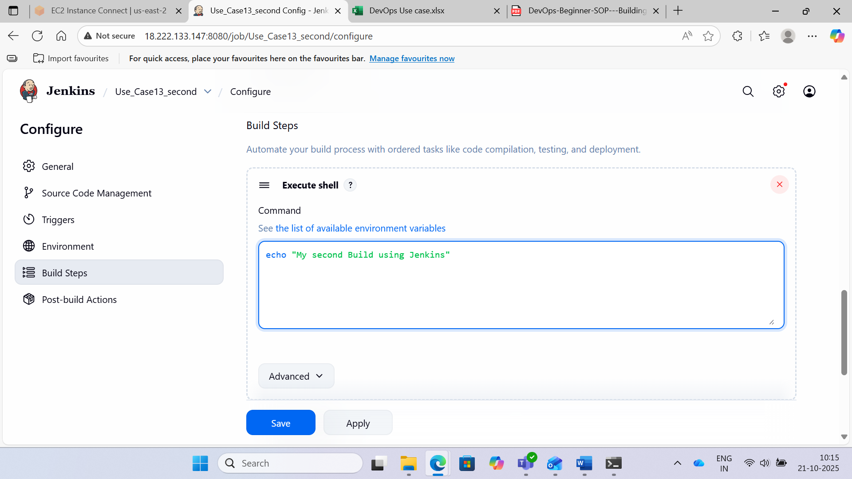

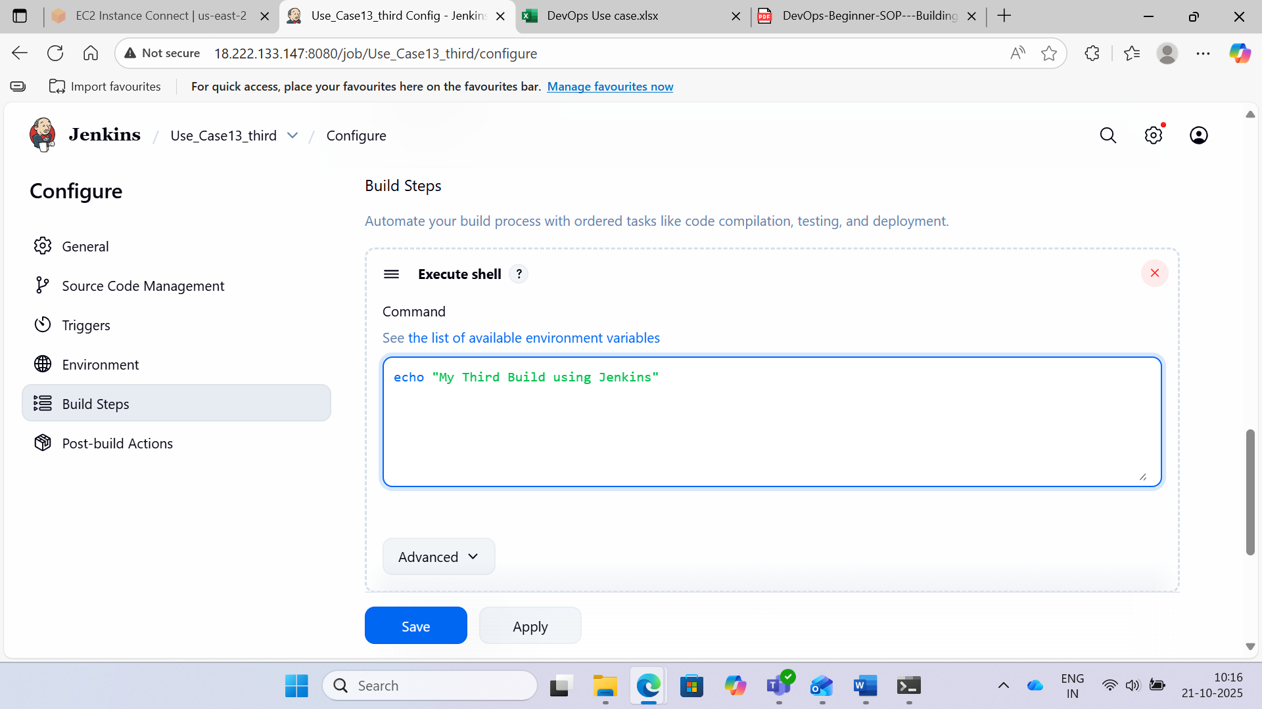

Step 5:- Select the first job and click on configure and under PostBuildActoins select Build other project by providing Second Build. Repeat the same for Second Build.

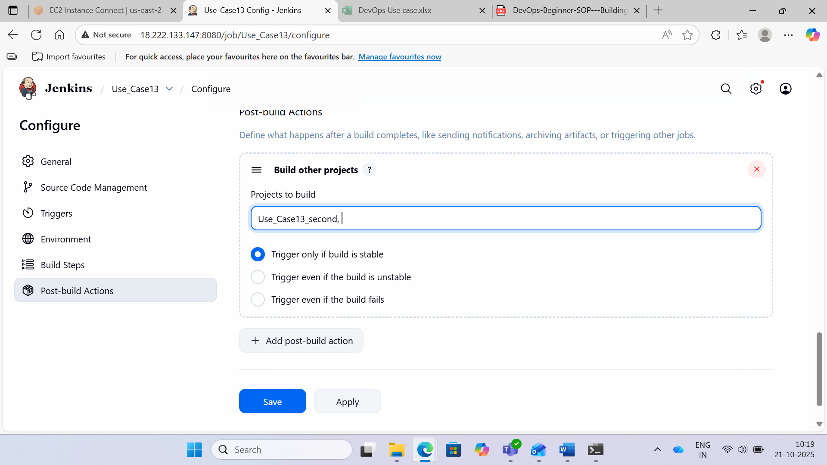

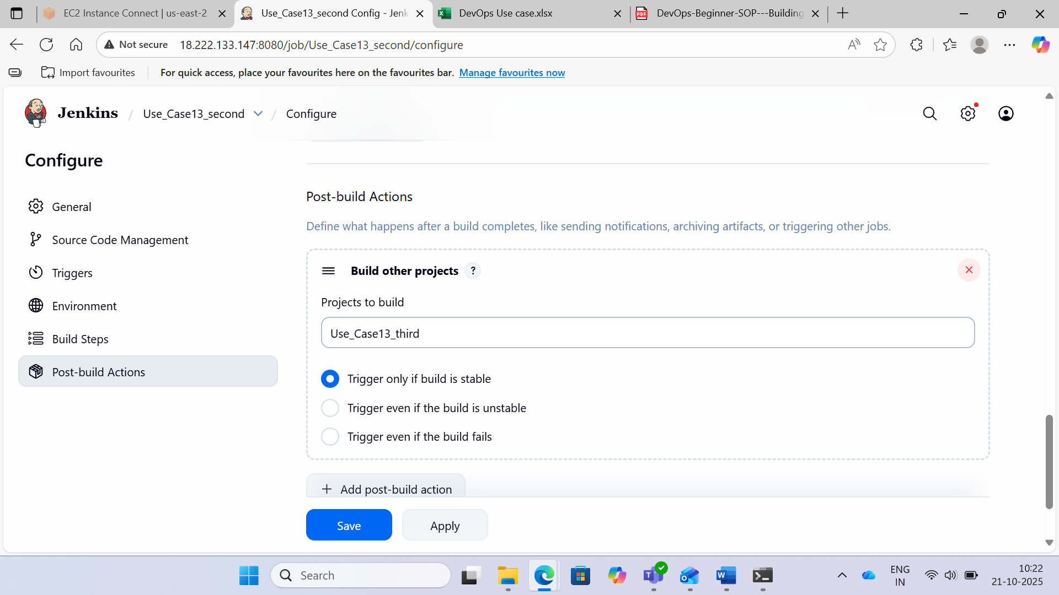

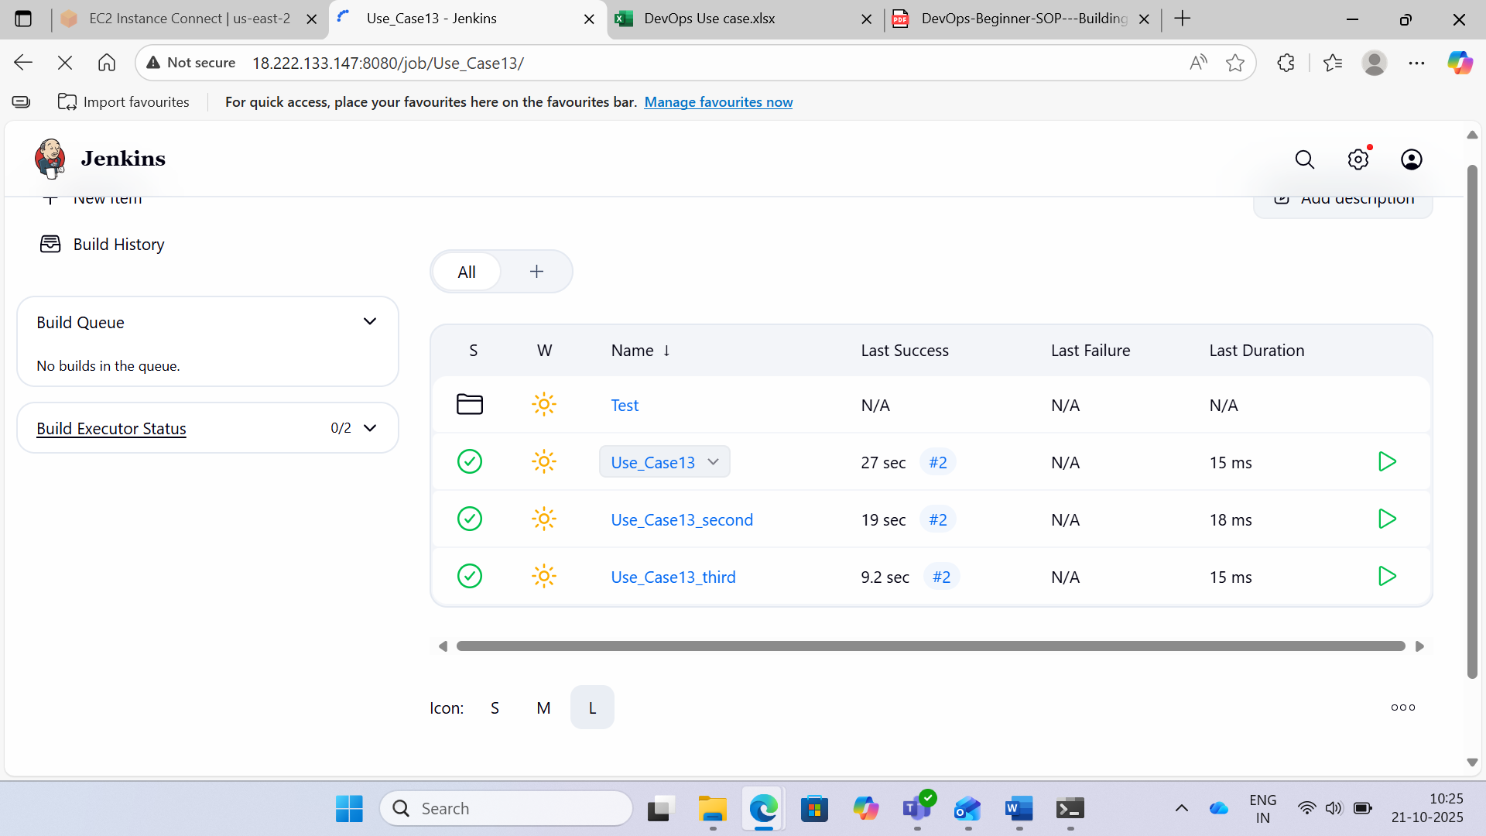

**Use Case 15**

Case 15: Parameterizing Builds

Step 1:- Create a Linux EC2 instance and install Jenkins.



Step 2:- Create a basic project to add the parameters:

1. Create a new job by entering the item name as Usecase15 and choose the Freestyle project.
2. Click OK.
3. In the configuration page, select the checkbox - This project is parameterized.
4. Create string parameters:

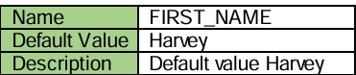

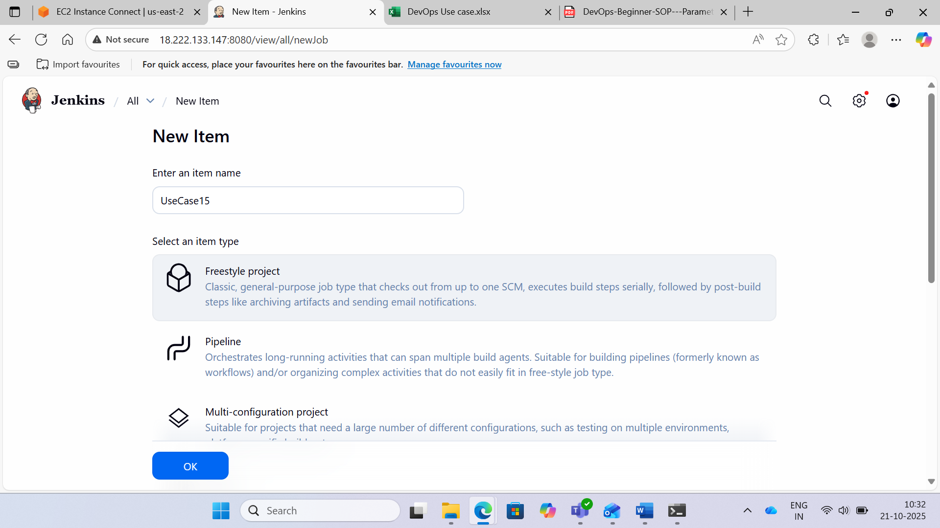

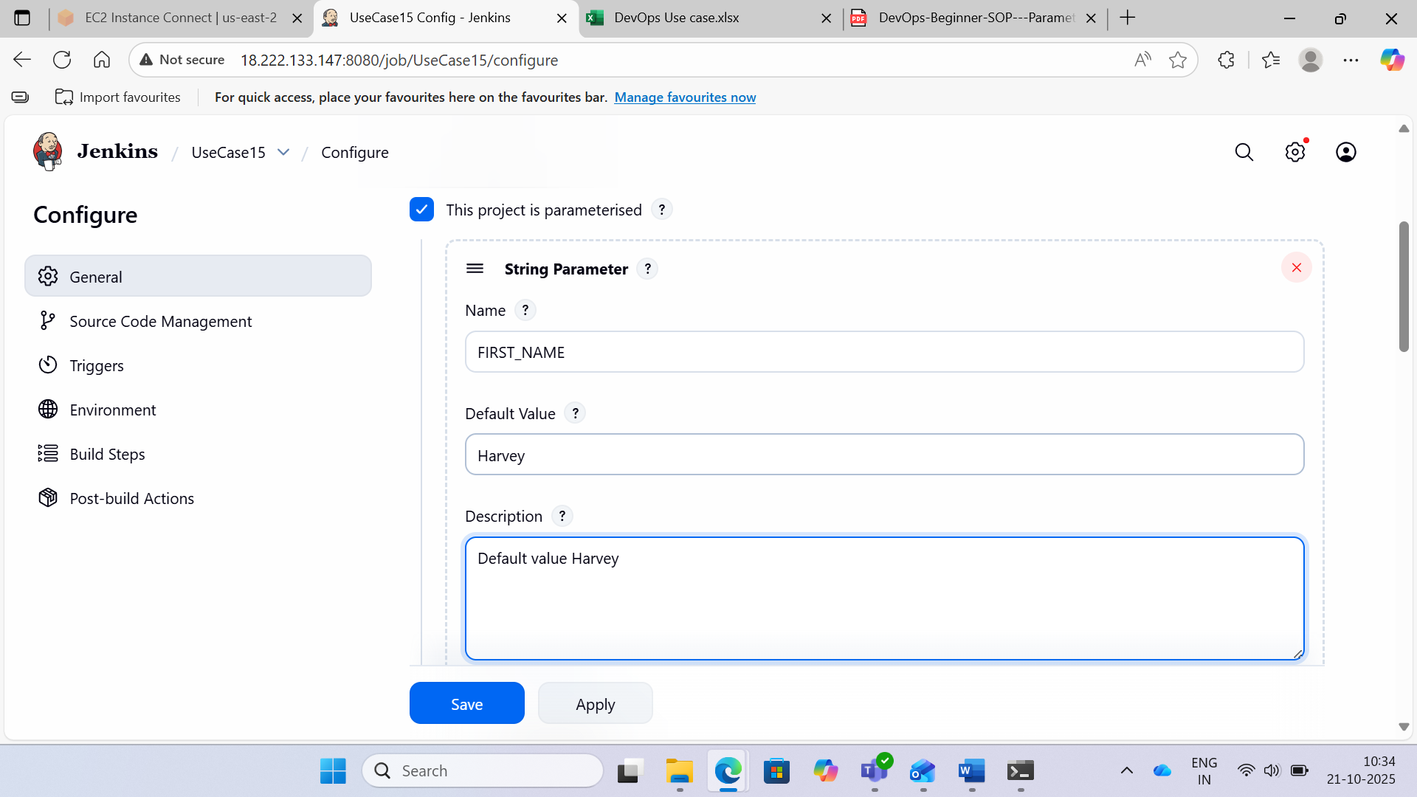

Step 3:- Add another string parameter

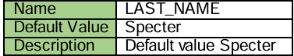

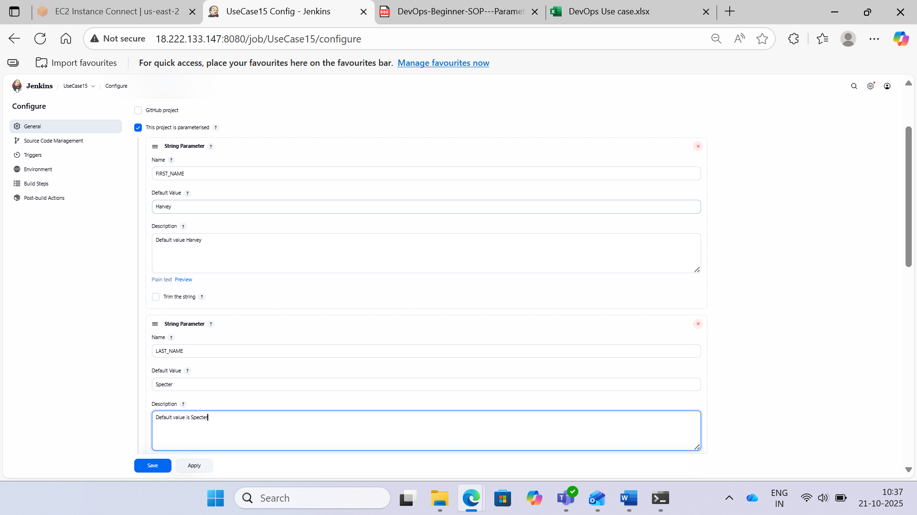

Step 4:- Go to the Build section, and add a Build Step – Execute Shell and type the following command

(Execute shell to print the names)

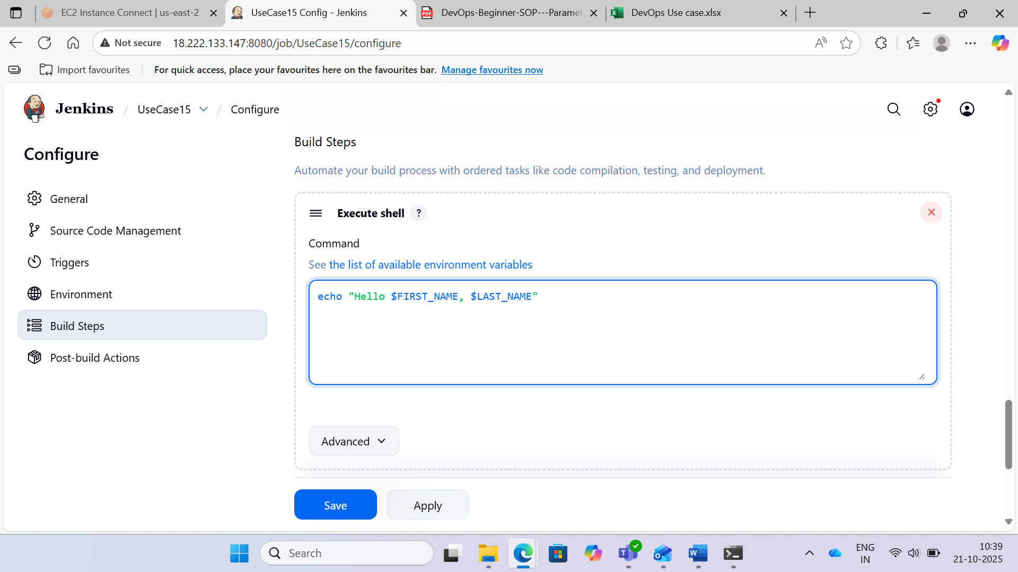

Step 5:- Click Save. Build the project

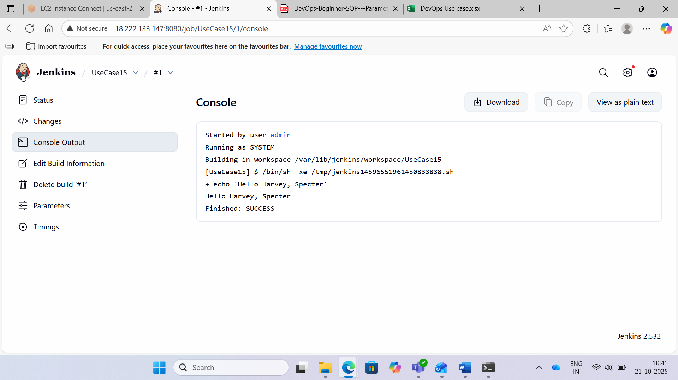

Step 6:- Accept a string parameter

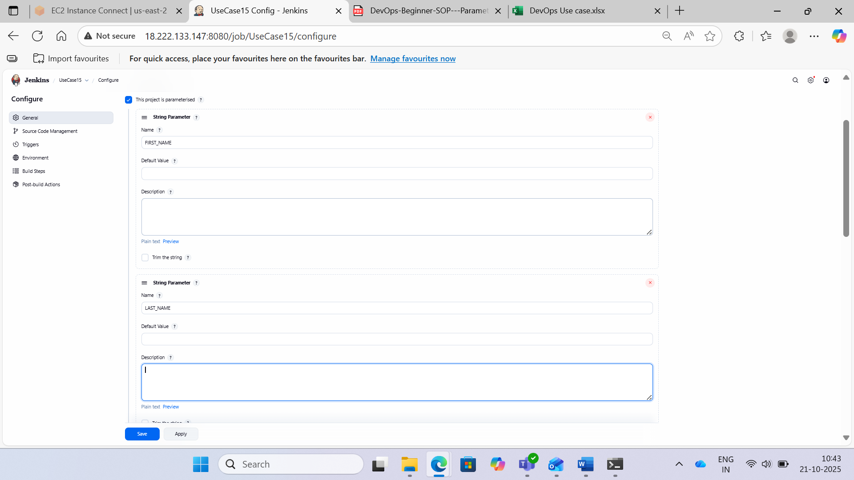

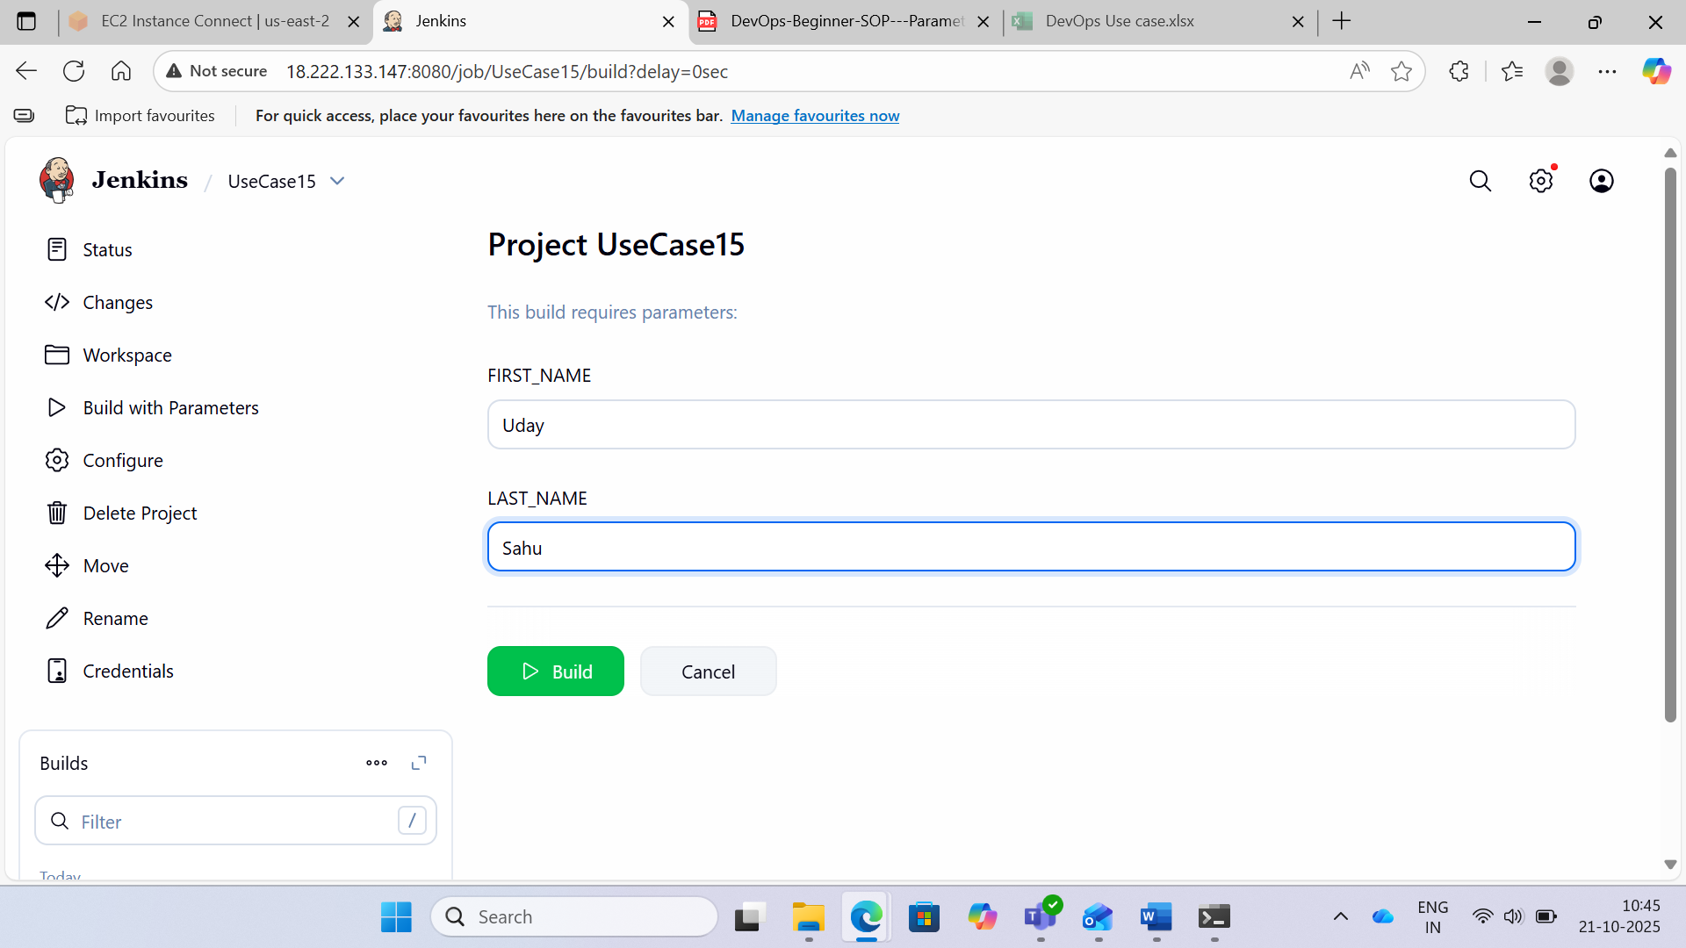

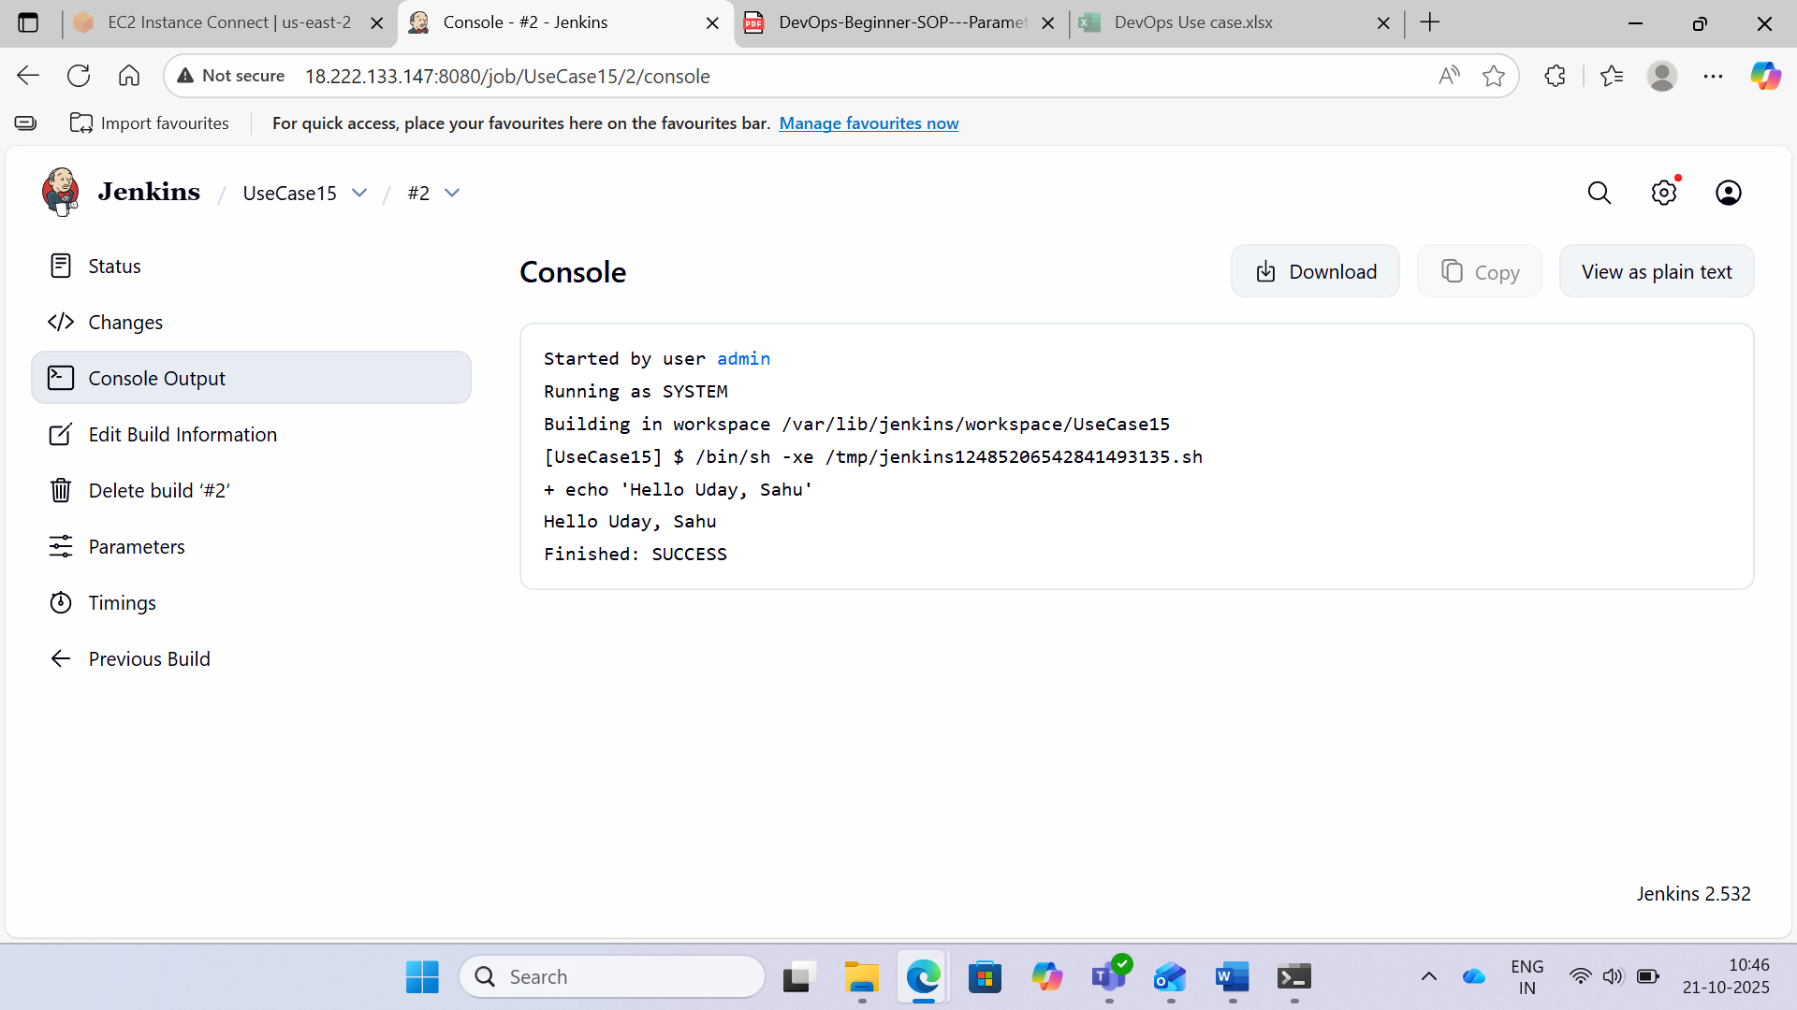

**Use Case 17**

Case 17: Configure RHEL Jenkins Agent

Step 1:- Login to Jenkins rhel server using admin

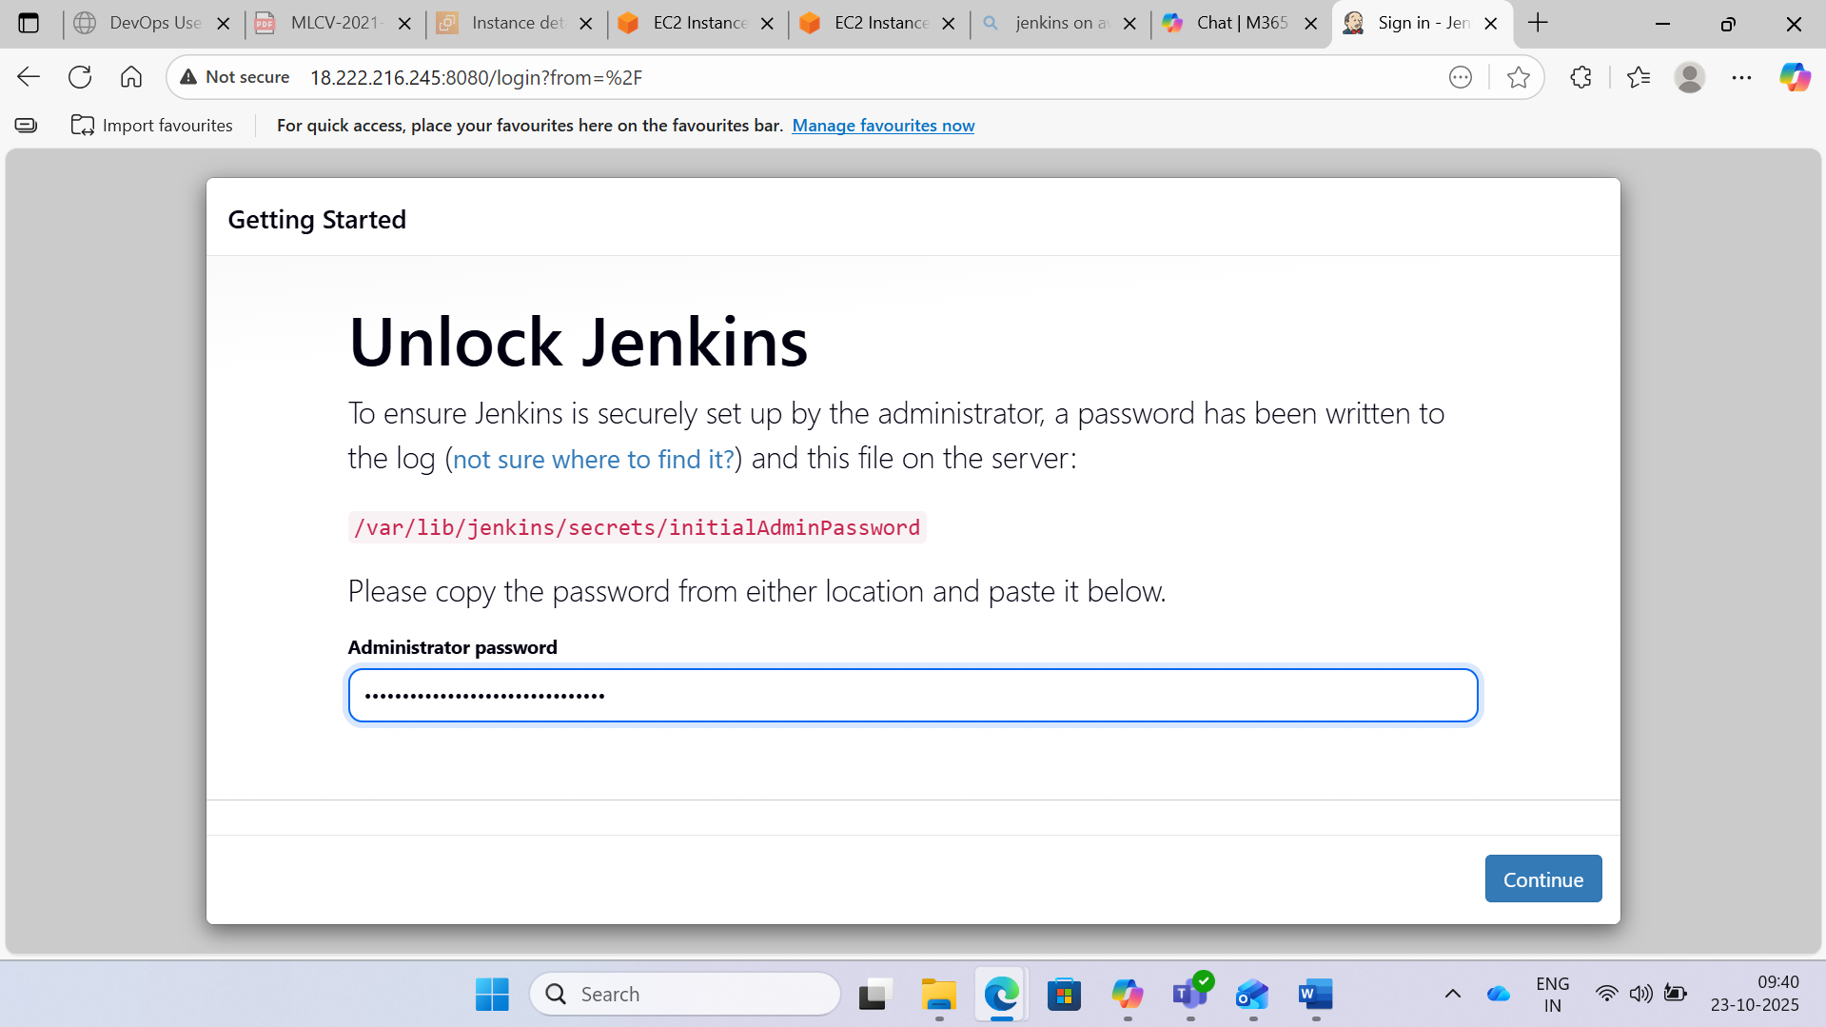

Step 2 : Click on Manage Jenkins > Manage Nodes

Click on New node and select Permanent Agent. Provide a Name for the Agent.

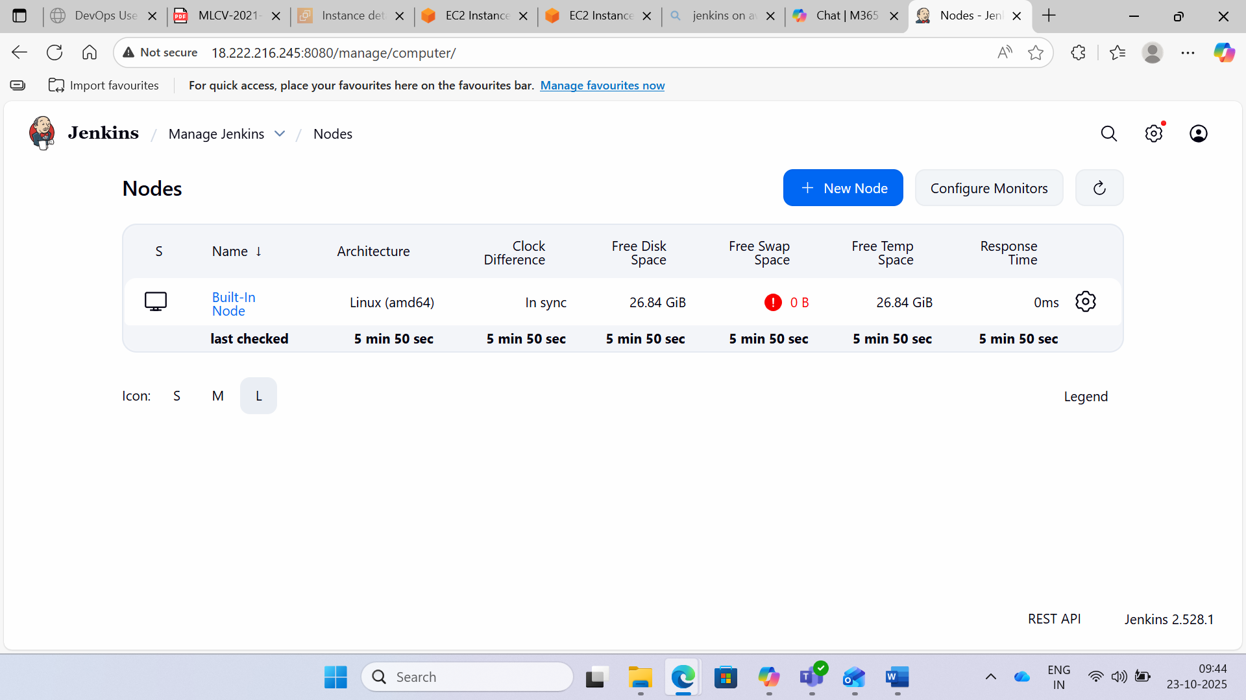

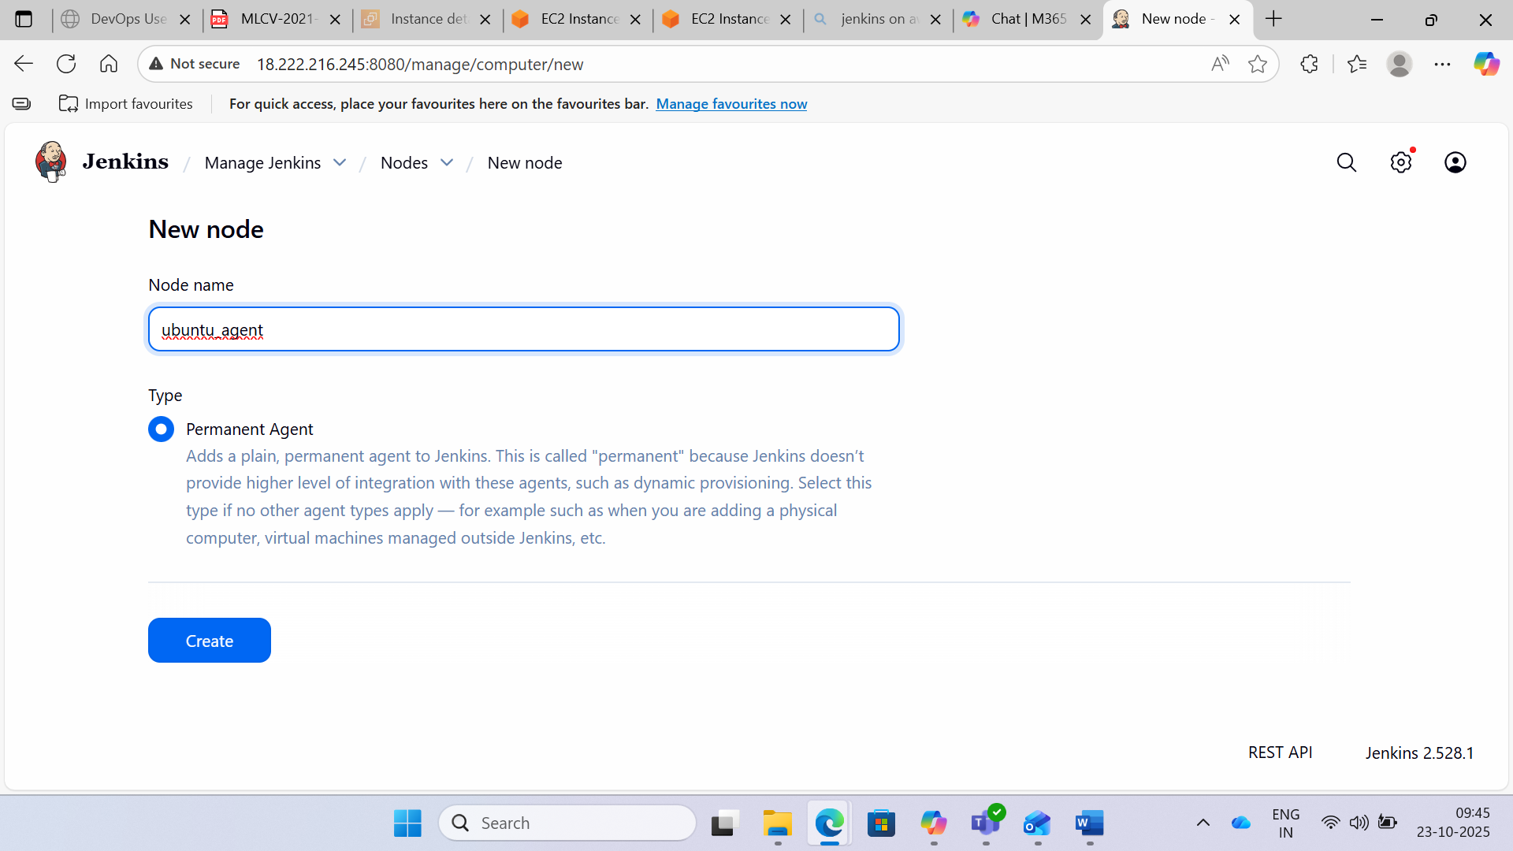

Step 3:- In the resultant window provide the details as shown below:

• Number of Executors: Update it according the project requirement and also capacity of the server. This number means how many jobs can run parallel

• Remote root directory: Path where the Jenkins Workspace will be checked out

• Labels: Identifier which will be used in Job while running it against any node

• Launch Method: Launch via SSH

• Host: Server Name

• Credentials: User name and password to connect to the server

• Host Key Verification Strategy: Manually trusted Verification Strategy, CONFIGURE need to manually approve/disapprove the remote host key in Jenkins if it has changed. Once approved, the host key will be marked as trusted. The host key received on the initial connection will be automatically trusted

• Availability: This will decide if the node needs to be kept online or can be brought down if not used.

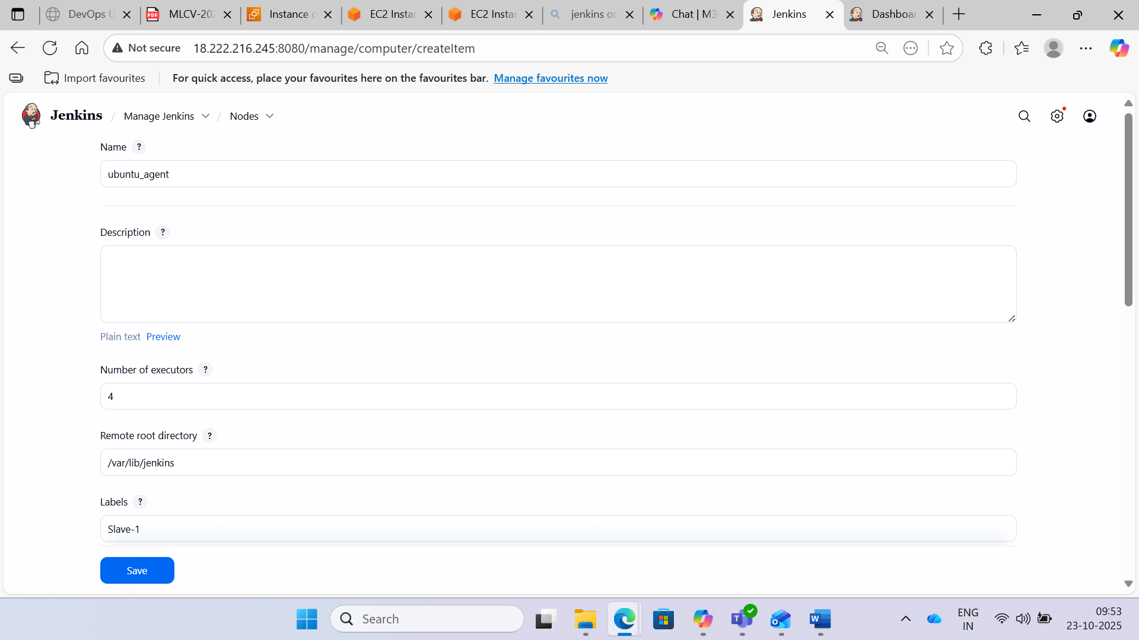

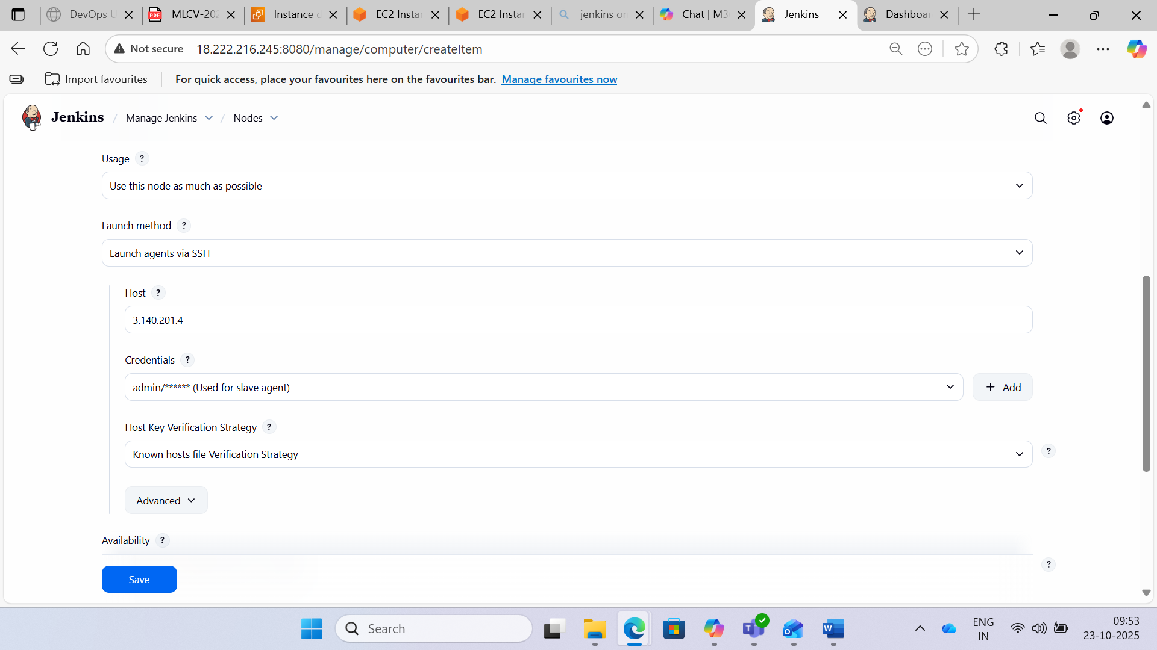

Step 4: Configure SSH between Jenkins Master and Agent

In master

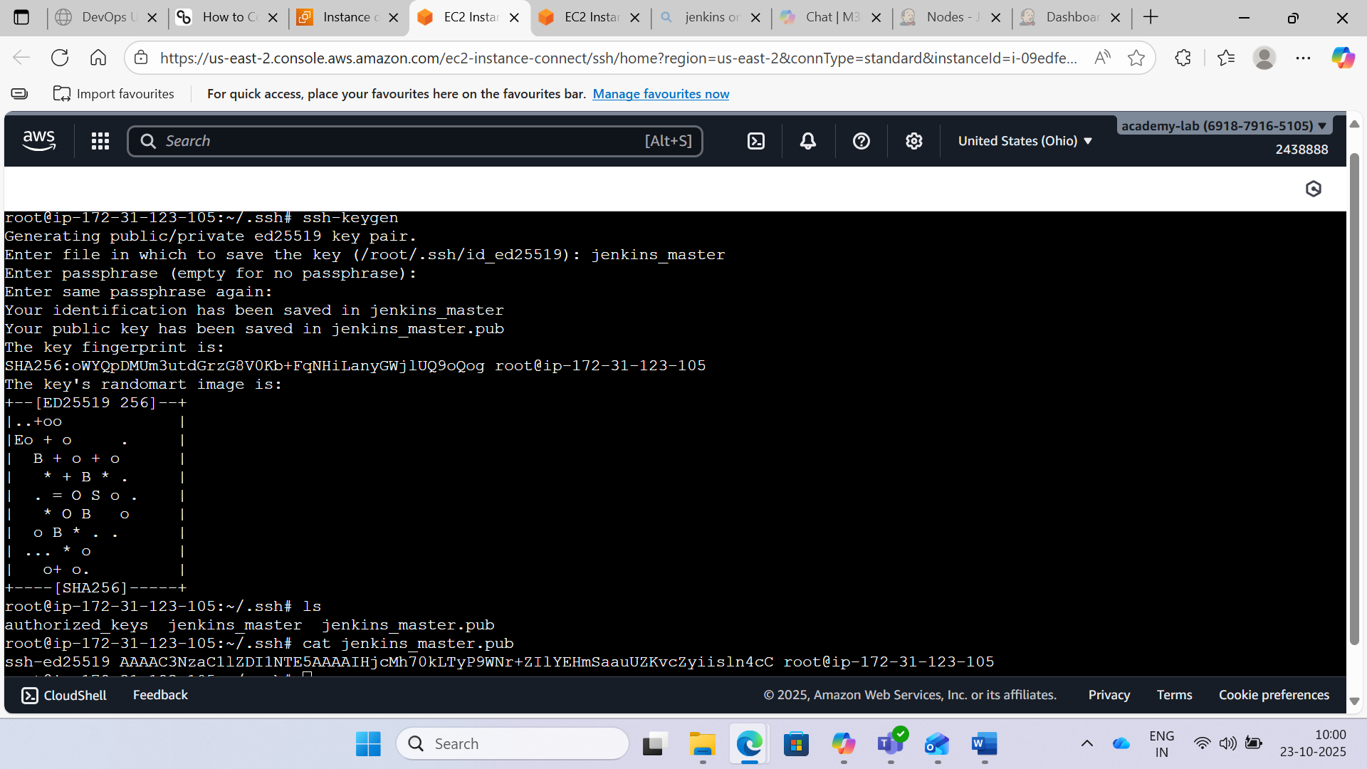

In slave

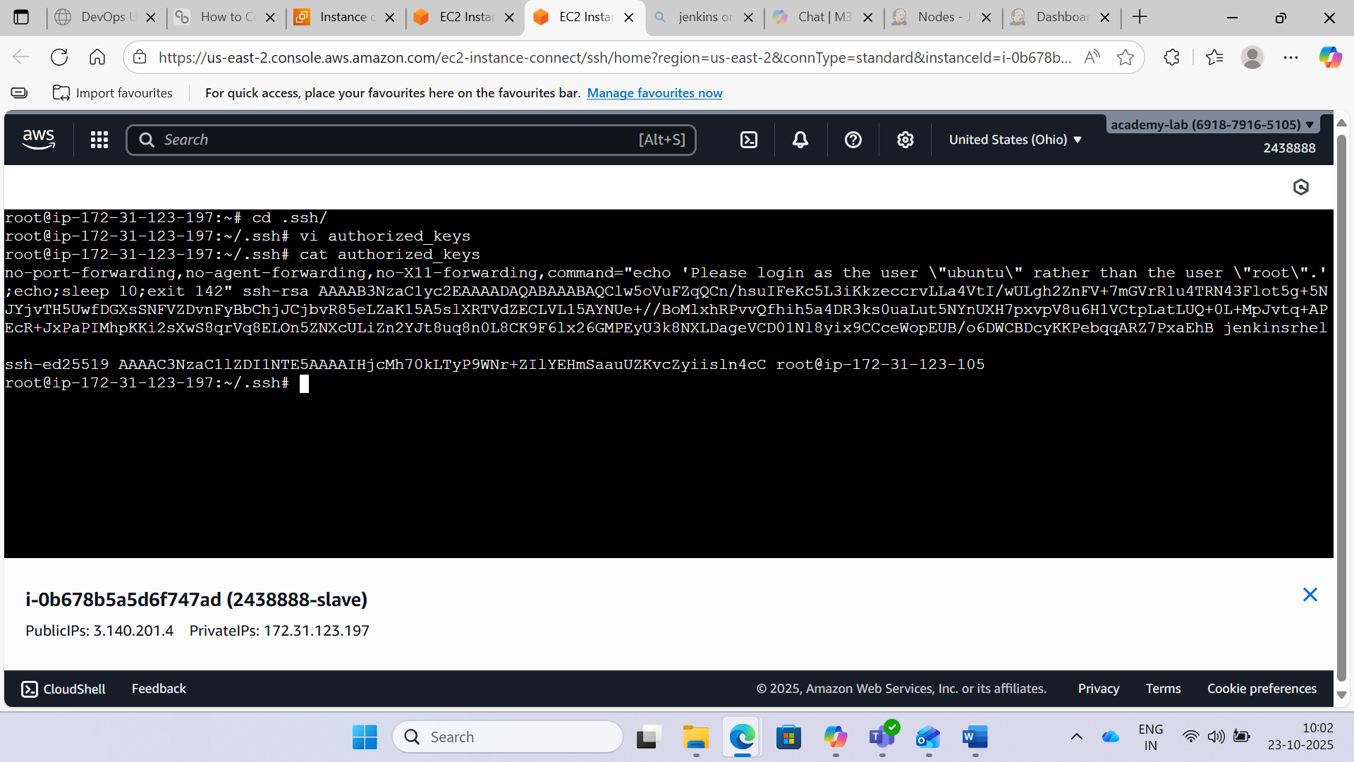

Step 5:- Once this is done, click on Launch agent as shown in the following screenshot. The agent will be connected to master if there are no issues in SSH and credentials set up.

To do so, follow these steps:

1. Go to slave agent, create a remote root directory such as “mkdir /root/jenkins”
2. Then cd to “/.ssh”, and do execute “ssh-keygen”. Copy the public key to authorized_key file.
3. Copy the private key and paste it in manage node-> Add credentials-> hostname with private key.

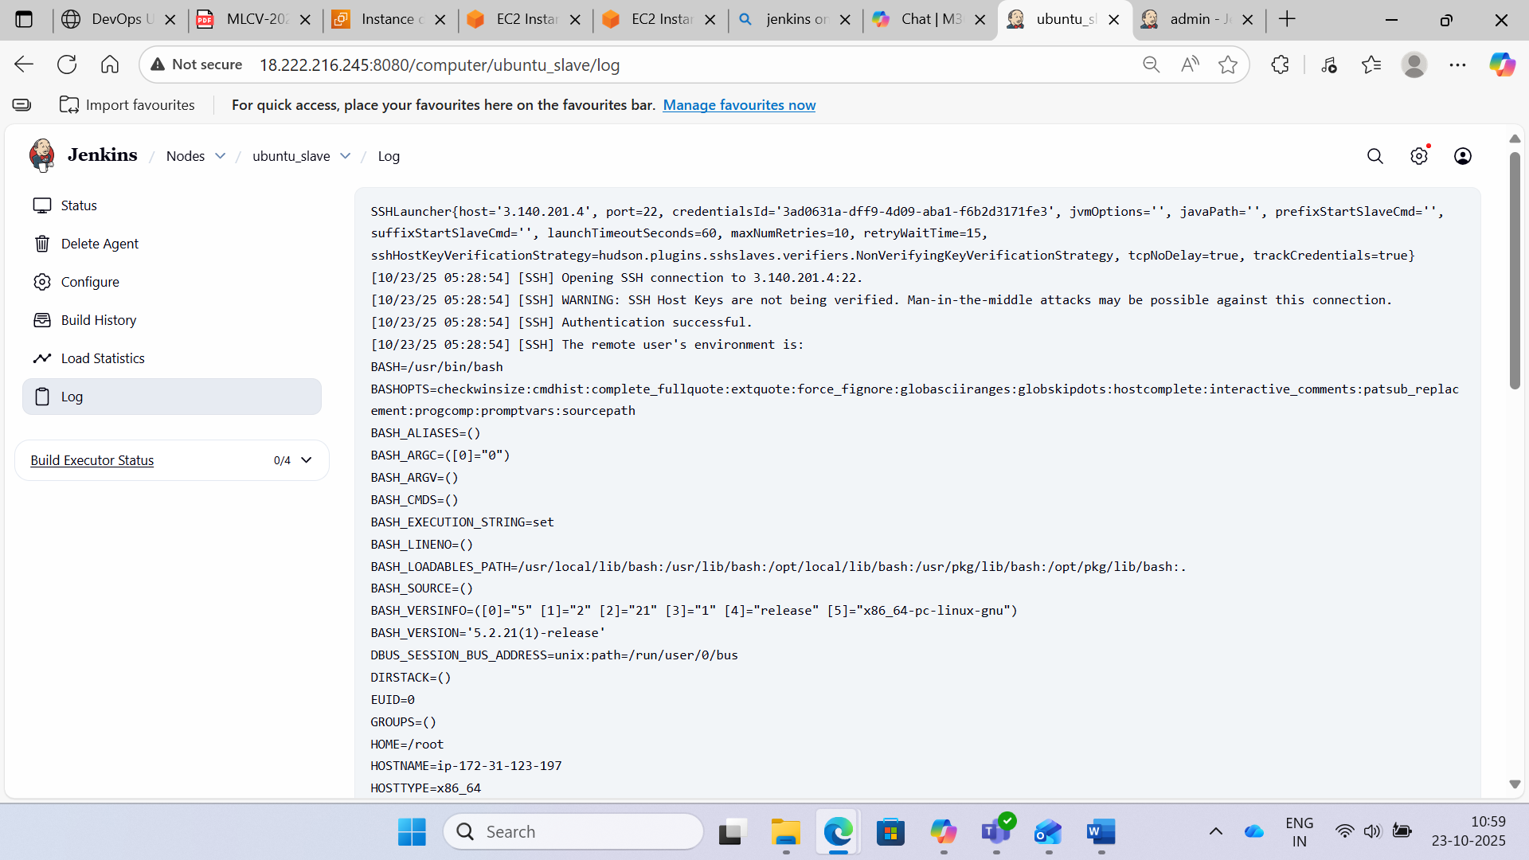

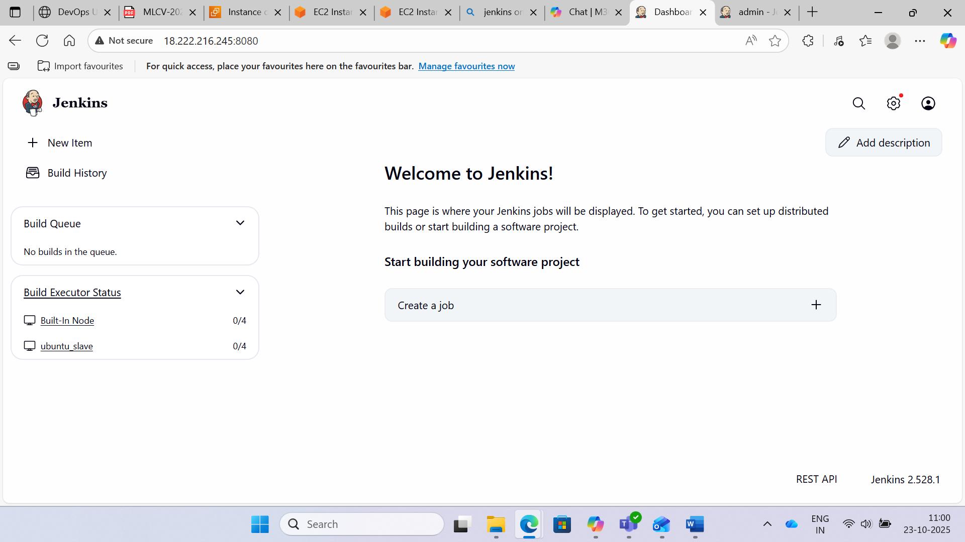

**Use Case 18**

**Case 18:** Passwordless Authentication between Primary and Secondary Servers

Step 1: Create new servers, and try for passwordless authentication

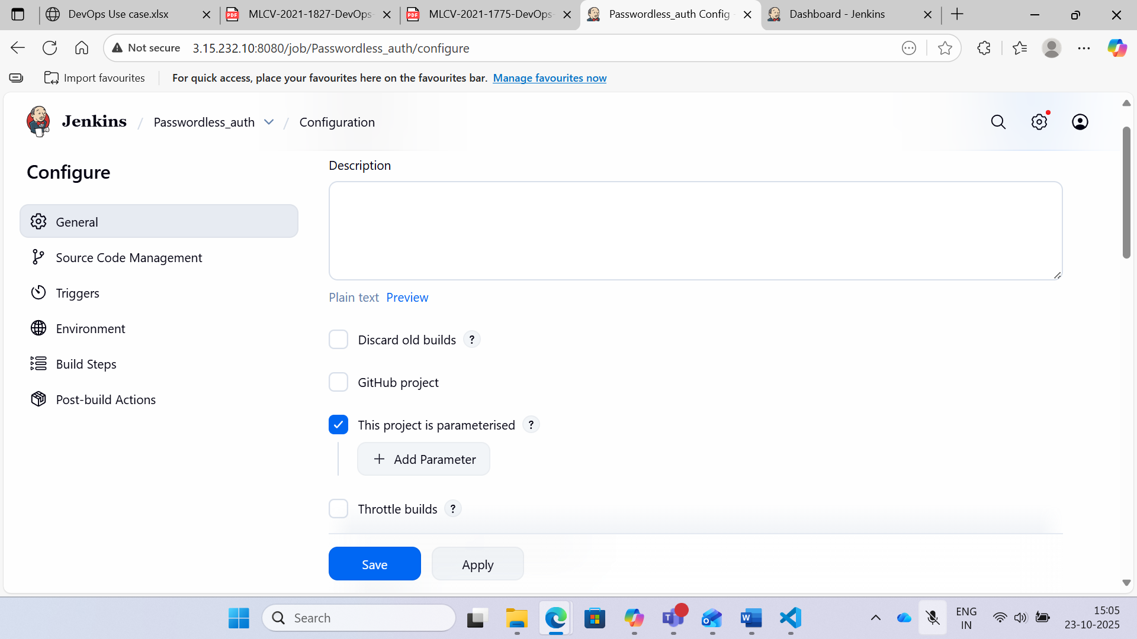

Step 2: Click the Add Parameter button and specify the following pieces of information:

1. Type: the data type for the parameter (string, Boolean, etc.)
2. Name: the name by which the parameter will be identified
3. Default value: an optional value that will be used when a user does not specify one
4. Description: optional text that describes how the parameter is used

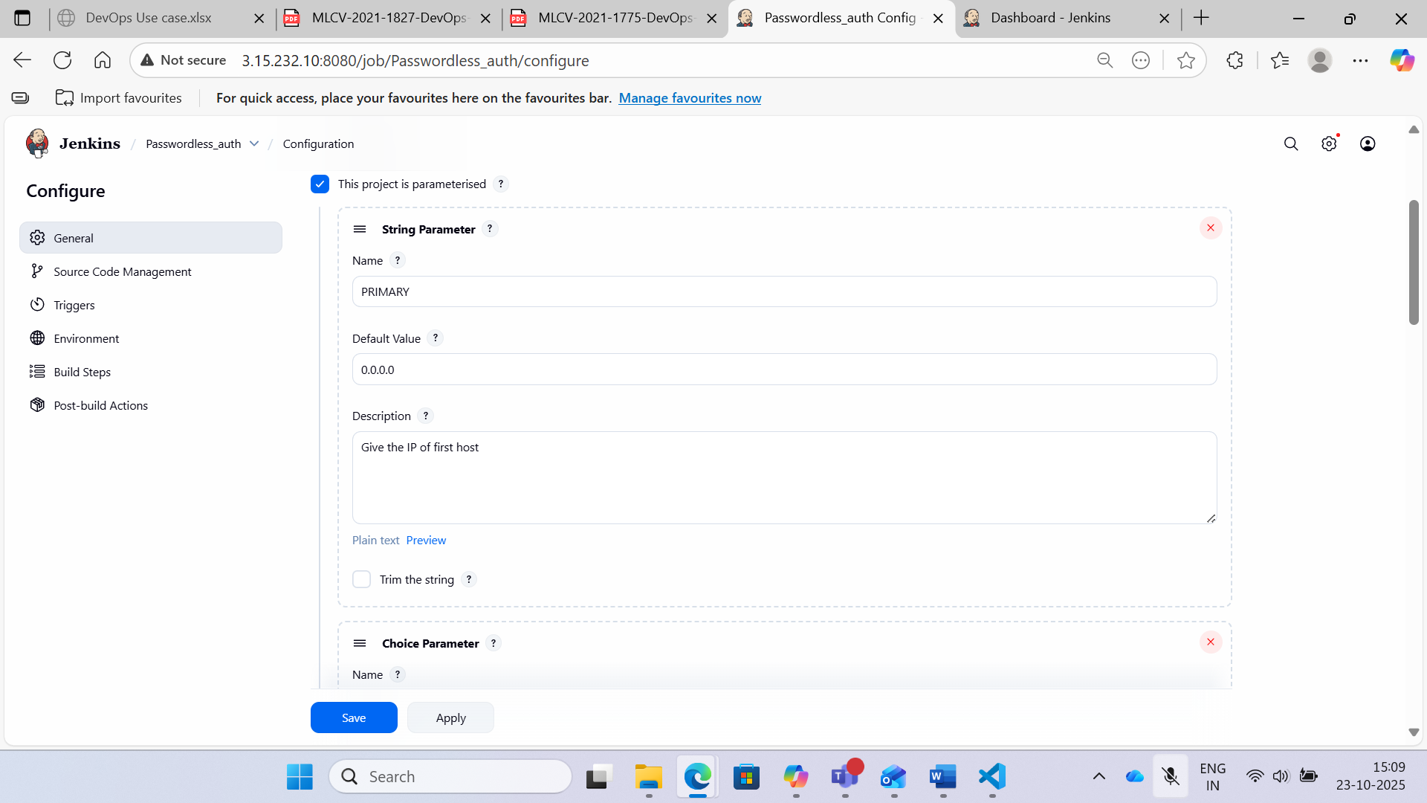

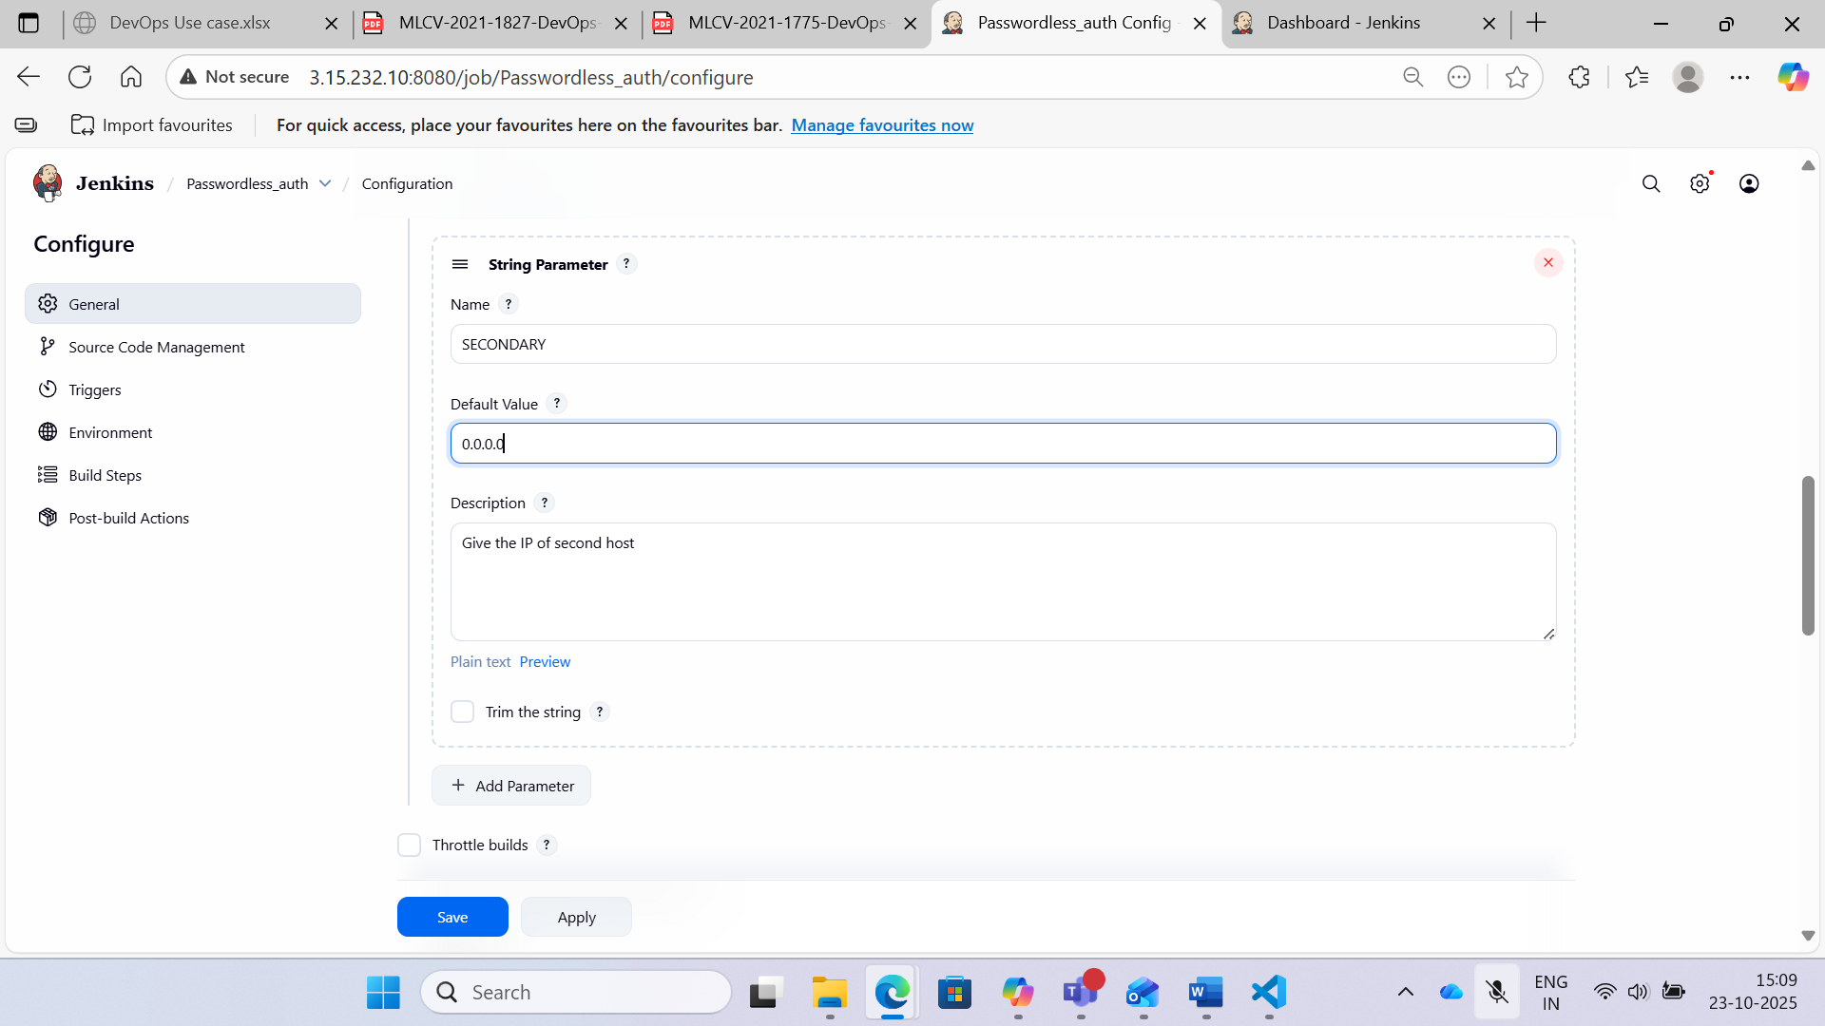

Step 3: After adding the parameters with IP values, provide the shell script under Build tab:

Provide primary and secondary server IPs value to the shell script:

primary_ip=$PRIMARY

secondary_ip=$SECONDARY

USERNAME=$USERNAME

# Add SSH keys to known_hosts

ssh-keyscan -H "$primary_ip" >> /var/lib/jenkins/.ssh/known_hosts

ssh-keyscan -H "$secondary_ip" >> /var/lib/jenkins/.ssh/known_hosts

# Test SSH from Primary to Secondary

ssh $USERNAME@"$primary_ip" << EOF

ssh -o StrictHostKeyChecking=no $USERNAME@$secondary_ip

EOF

# Test SSH from Secondary to Primary

ssh $USERNAME@"$secondary_ip" << EOF

ssh -o StrictHostKeyChecking=no $USERNAME@$primary_ip

EOF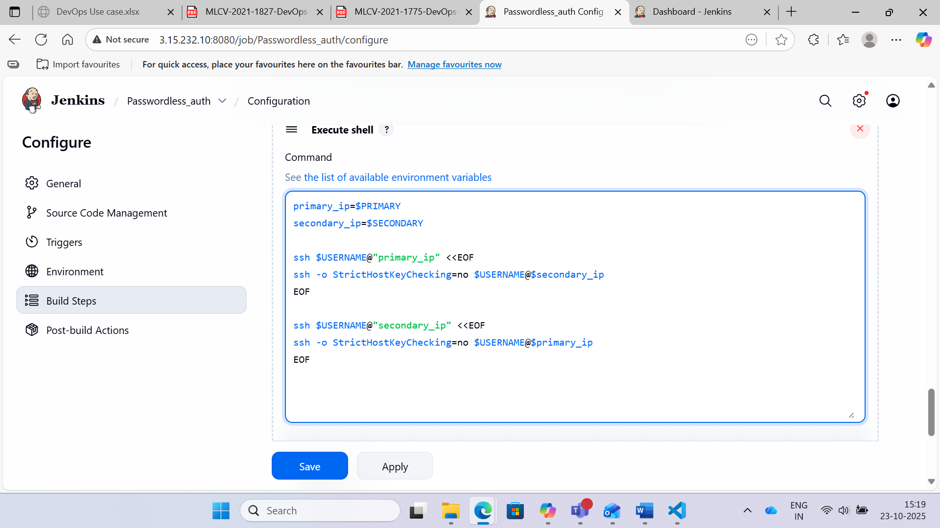

Step 4: Build with parameters

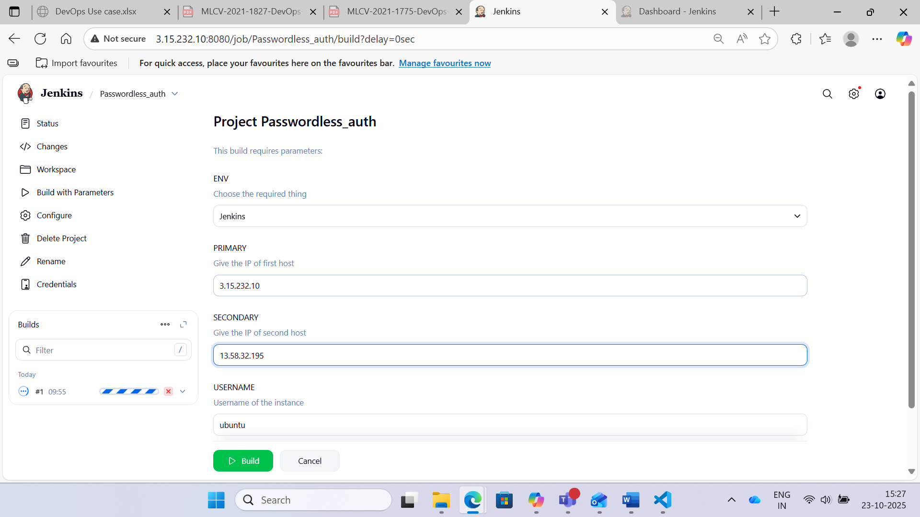

**Use Case 19**

Case 19: Jenkins Admin Role Configuration

Step 1: Install the Jenkins and docker in AWS machine and execute the build steps.



Step 2: Click the Manage Jenkins

Click the Manage plugins

Click the Available tab and go to Filter column and search Role-based Authorization strategy

Click ok once you selected the above role plugin and install the same. Go to manage Jenkins and select the Configure Global Security.

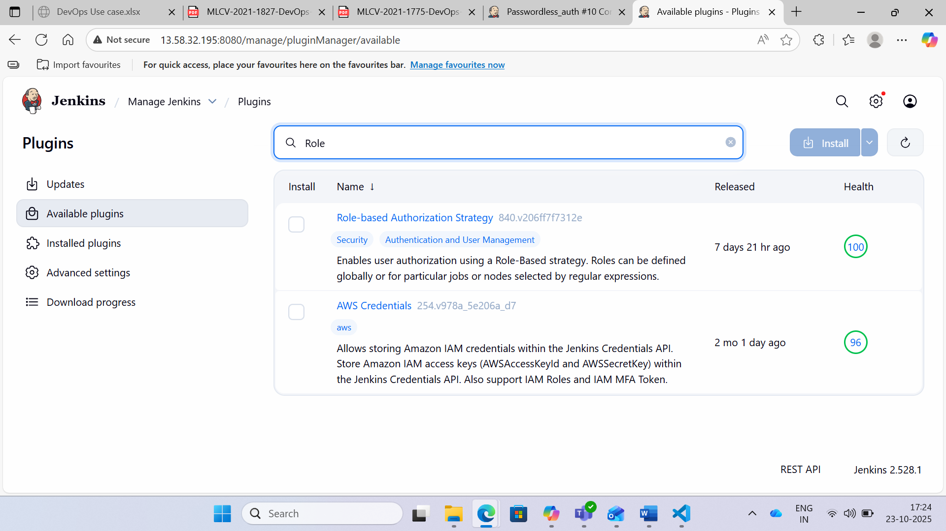

Step 3: Select the role based strategy from Authorization category.

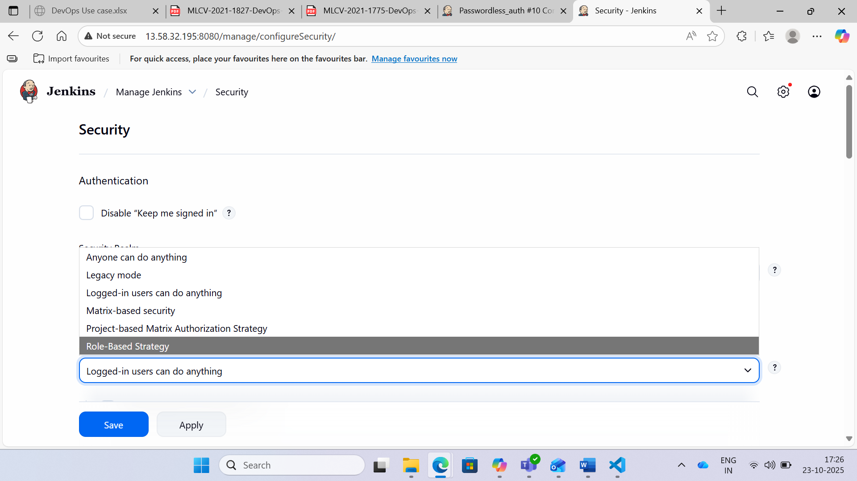

Step 4: Go to Manage Jenkins and select the Manage users and create a new user.

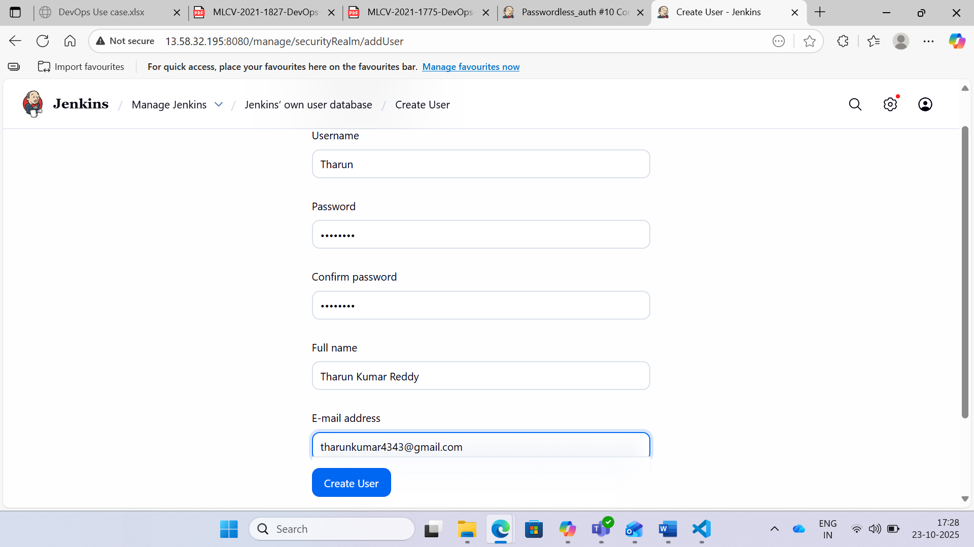

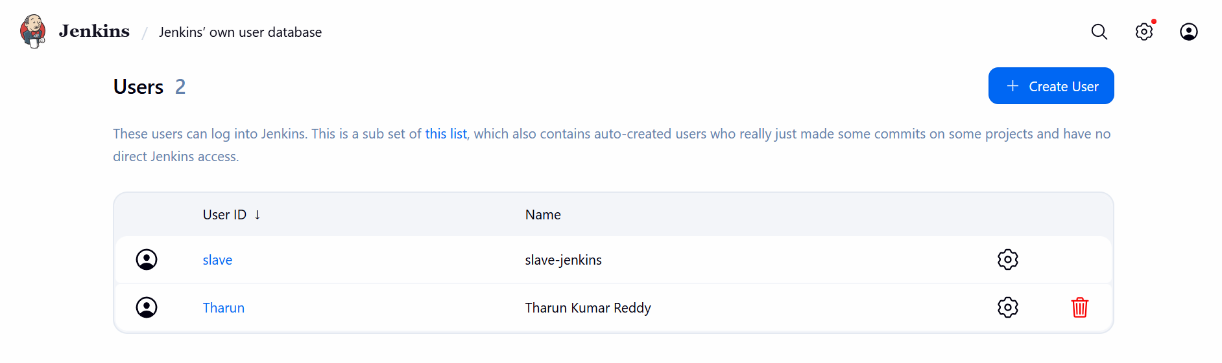

Step 5: Once the user is created, go to manage Jenkins and select the Manage and assign roles. Click the Manage roles link to create one more role called Dev.

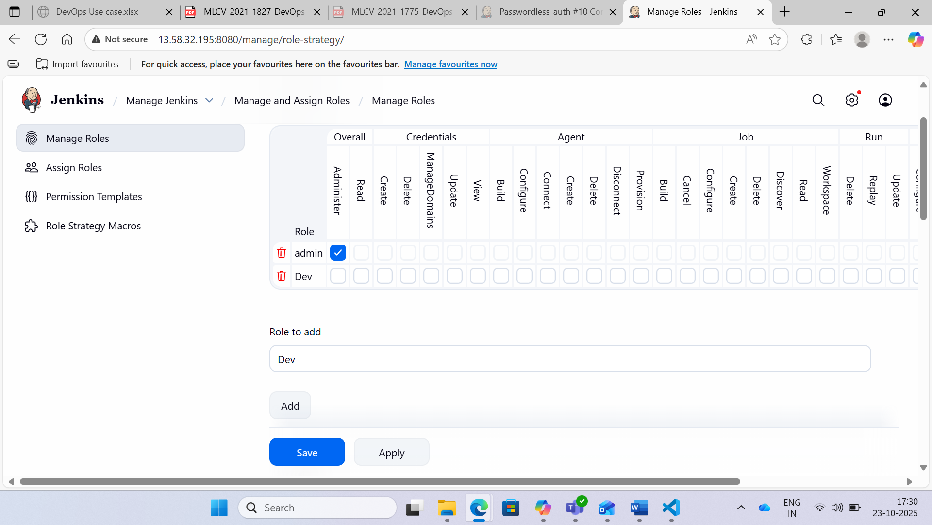

Step 6: Provide Read permission as shown in the below screenshot for Dev Role.

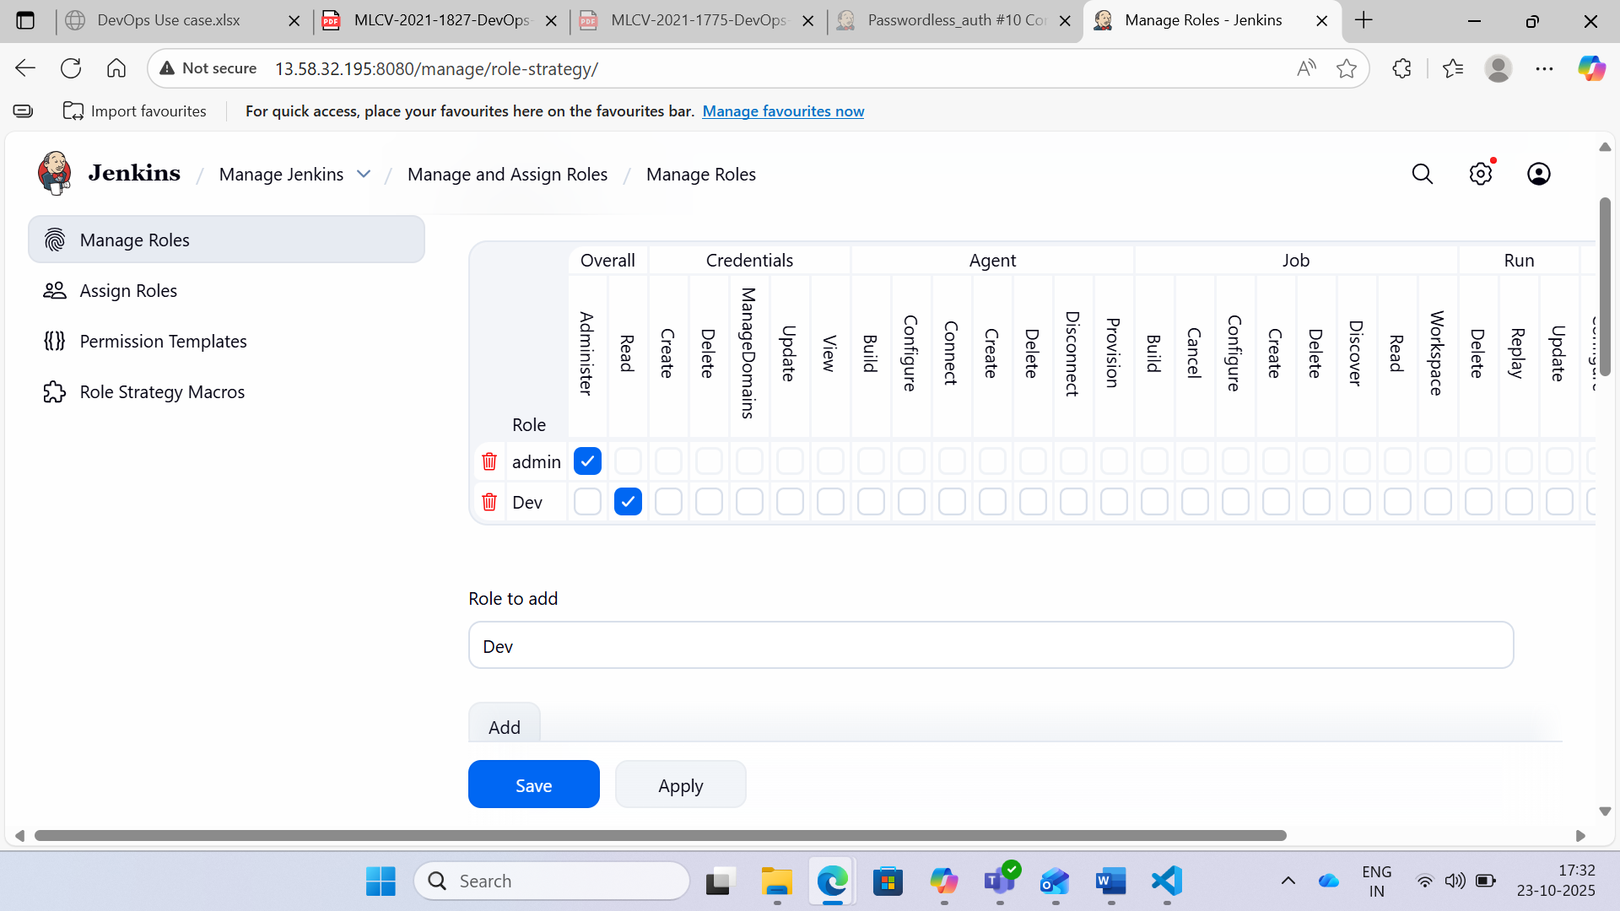

Step 7: Go to project role and enter the project name and assign the roles appropriately.

Once you select the pattern as per the below screen and save it.

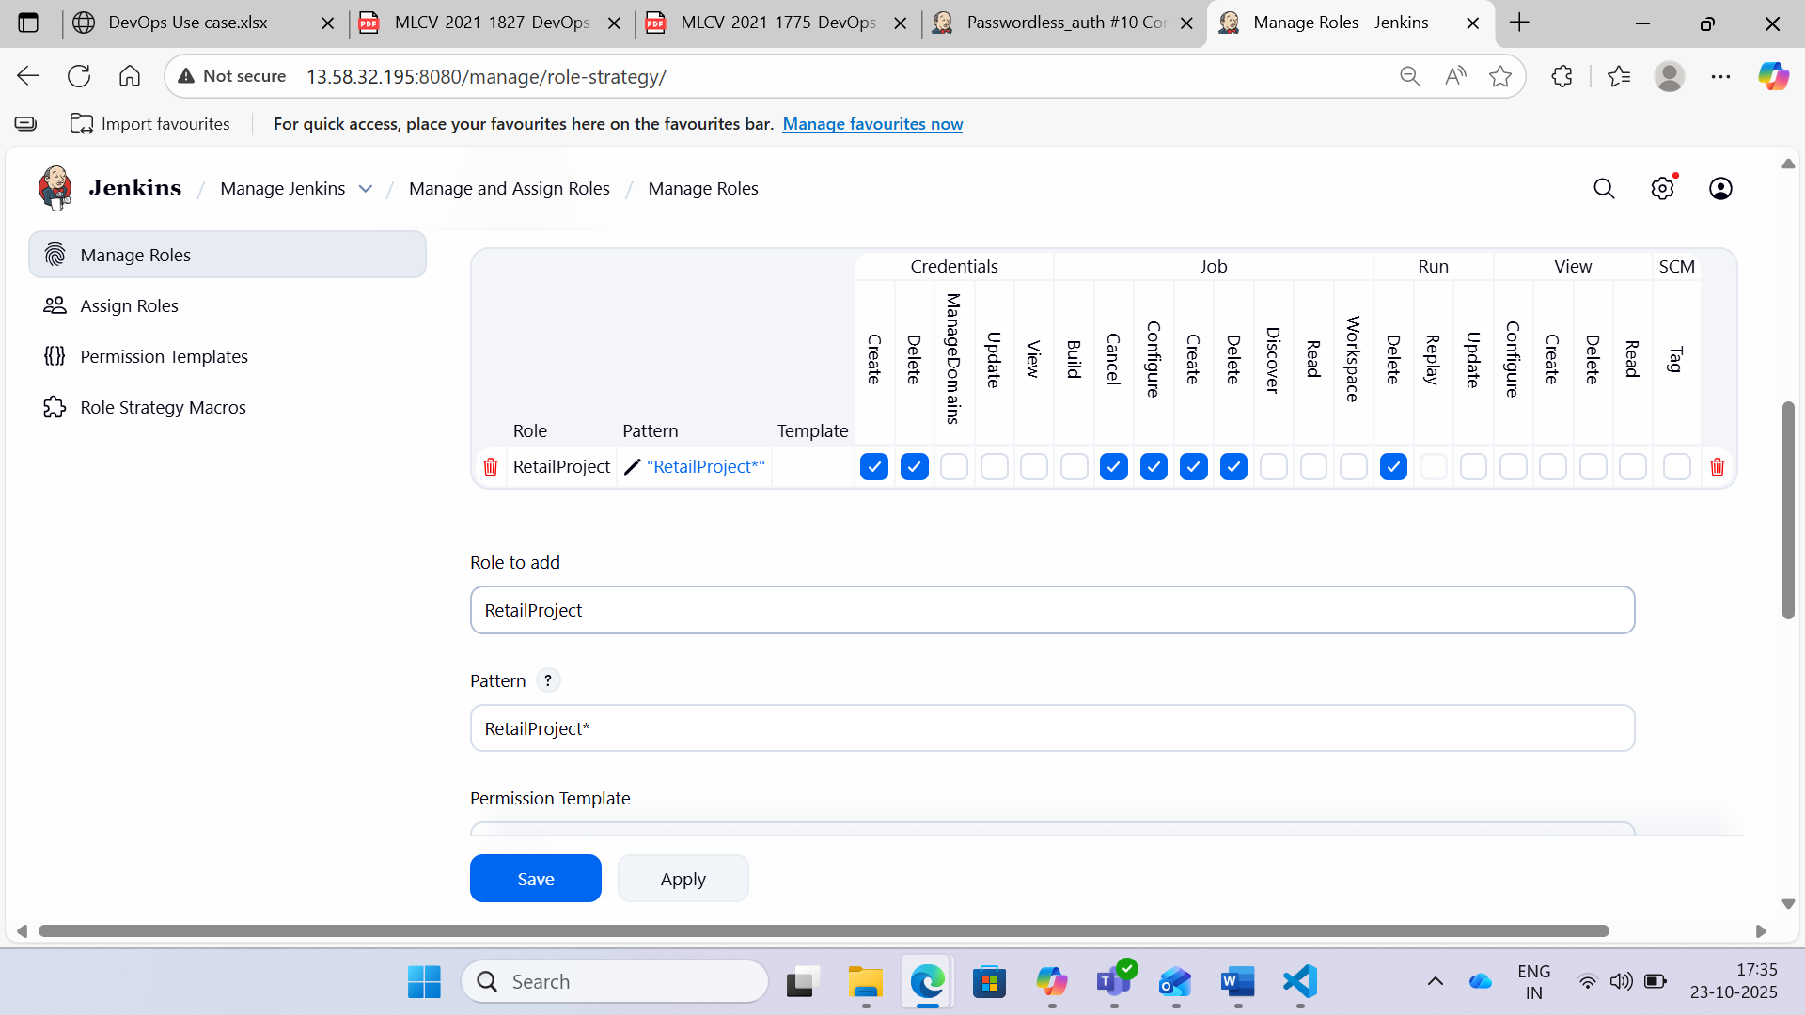

Step 8: Choose Assign roles link as shown in the below screen.

There are two roles: one is Global and the other one is project perspective.

Create a user and assign it to a specific role as shown in the below screens.

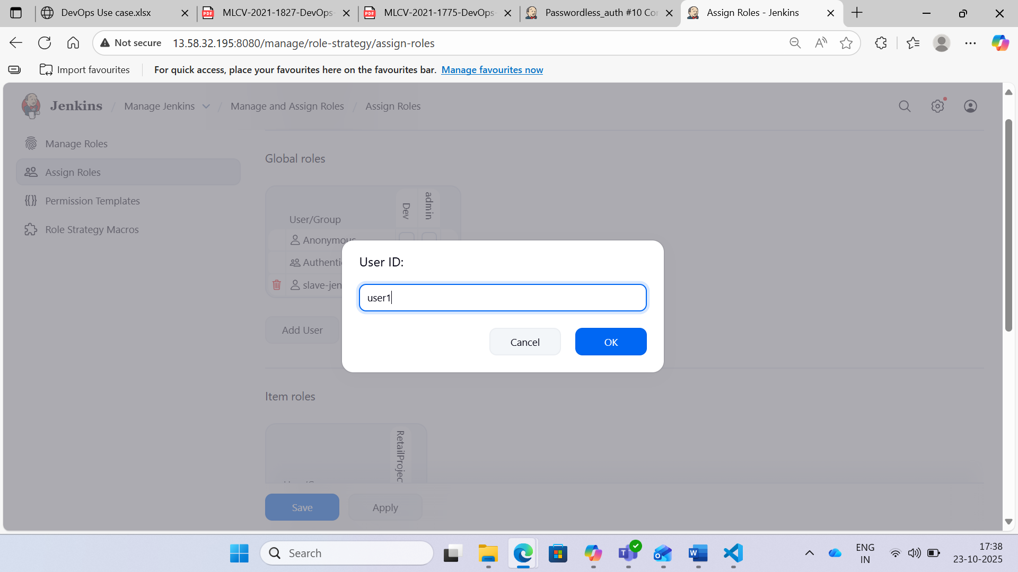

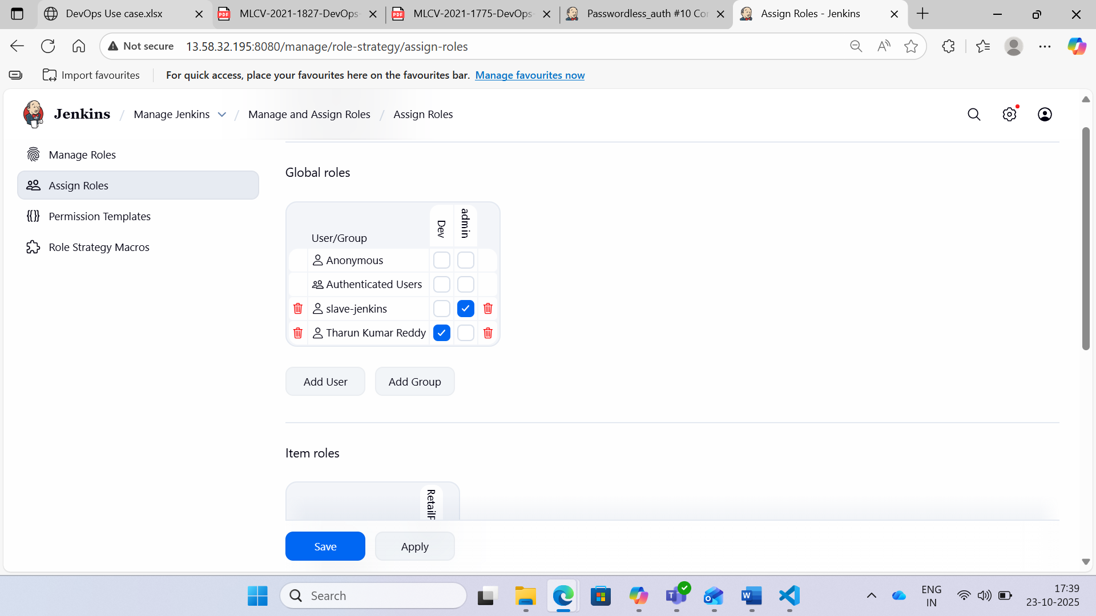

Step 9: Go to Item roles and add the user and assign to the project.

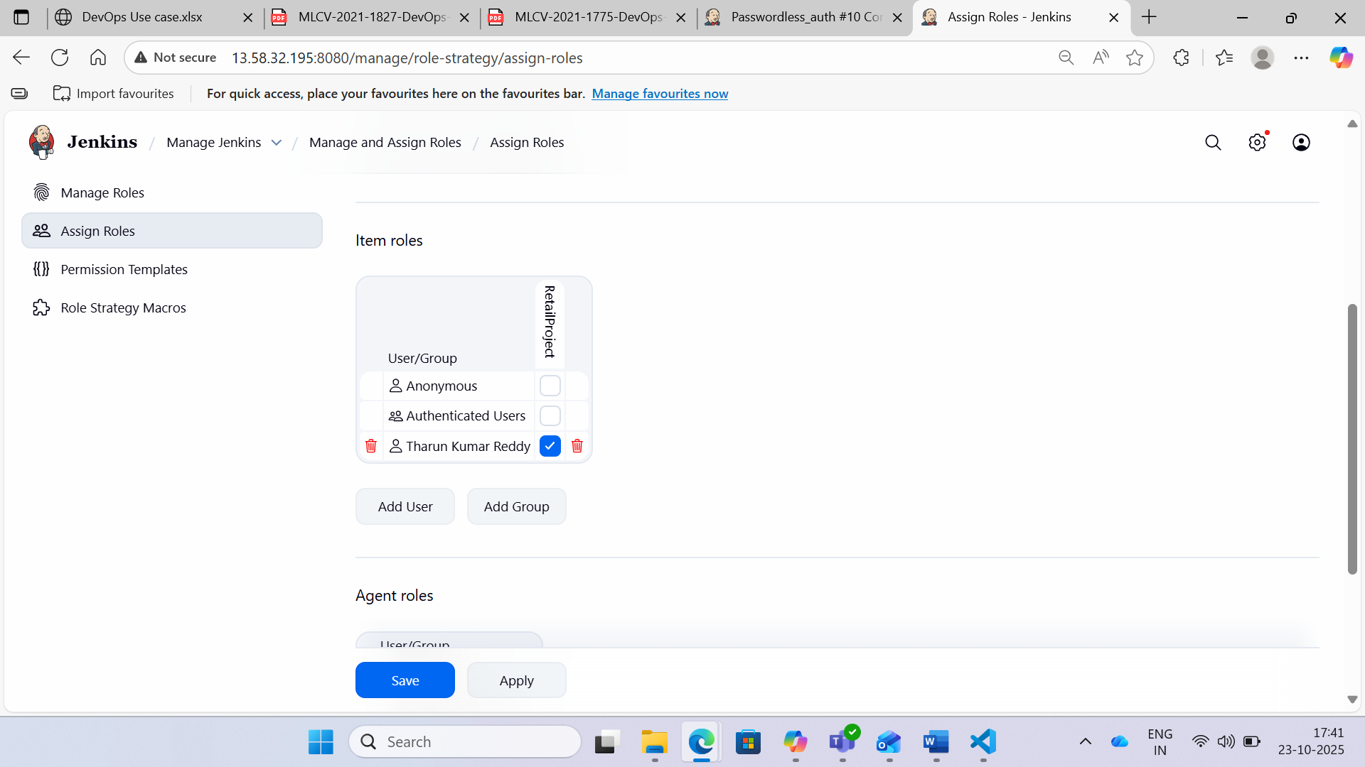

Step 10: Create several jobs with different names such as project1, finance_job, RetailProject, RetailProject_Job etc.

Then login as user you created and check what you can do with that.

